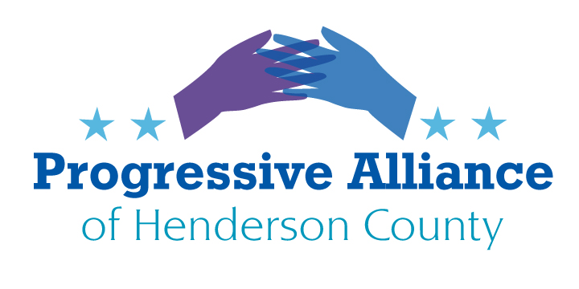
Post Card Party #253 November 18, 2022
All three of today’s topics involve issues which must be resolved during Congress’ lame-duck session in November and December. Any which are not resolved by the end of the current House term will die, and efforts to pass them will have to begin again in January with new bills. With elections resolved, lame-duck sessions often result in meaningful legislation actually being passed.
Voting Rights
The John Lewis Voting Rights Advancement Act (VRAA), (H.R. 4/S.4), includes a modern formula to determine which states must secure federal approval for voting law changes. The new formula would assess which states have had repeated voting rights violations over the previous 25 years. States found to have excessive rights violations would be subject to federal oversight for ten years, with the opportunity to end federal oversight after that period. The VRAA will again provide the federal government with the tools necessary to combat voter suppression and help ensure every American’s right to vote.
The House passed the VRAA late last year. Now the Senate must act and pass this critical legislation to ensure our elections are fair and free for all voters.
Write to Sens. Burr and Tillis and urge them to vote to pass the VRAA during the upcoming lame-duck session.

Gun Show Loophole
H.R. 8 would close the “gun show loophole” by mandating that all sellers run potential buyer information through the FBI’s National Instant Criminal Background Check System (NICS), including online and private sales. The bill maintains some exceptions for law enforcement officials, loans for hunting and sporting events, and for transfer between family members.
The Enhanced Background Checks Act of 2021 would end the “Charleston loophole,” a gap in the law that allows some gun sales to proceed without a completed background check, as was the case with mass murderer Dylann Roof. With some purchases, the FBI’s NISC system is unable to make an immediate determination on a buyer. Under current law, the FBI has three business days to continue to investigate the buyer. If the FBI has not concluded the investigation after 3 days, the seller has the discretion to sell the firearm despite the lack of a completed background check. H.R. 1446 would close this loophole.
Both have passed the House.
Write to Sens. Burr and Tillis and urge them to co-sponsor Senate legislation equivalent to H.R. 8 and H.R. 1446, and vote in favor of said legislation during the upcoming lame-duck session.

Lower Prescription Drug Costs
To drive down the cost of prescription drugs for all Americans, House Democrats have introduced H.R. 3, The Elijah E. Cummings Lower Drug Costs Now Act designed to meaningfully decrease prescription costs.
The legislation’s key provisions include:
- Allowing Medicare to negotiate prescription drug prices and make those negotiated prices available to commercial health insurance plans.
- Capping Medicare beneficiaries’ out-of-pocket costs on prescription drugs at $2,000 per year.
- Requiring drug manufacturers to pay a rebate to the federal government if they increase prices faster than inflation.
- Reinvesting the savings into the National Institutes of Health and Food and Drug Administration to support the research and development of new treatments.
Write to Rep. Cawthorn and urge him to vote in favor of H.R. 3 during the upcoming lame-duck session.

