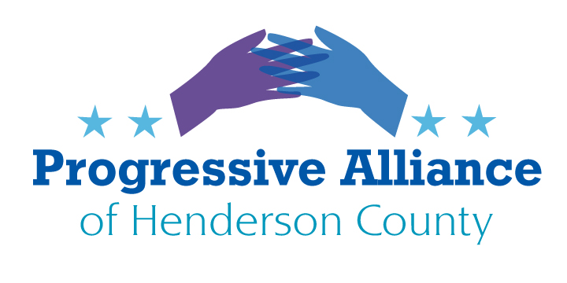

Virtual Postcard Party Suggestion Sheet #215 April 15, 2021

Gun Sense
Since 1994, over 3.5 million sales have been blocked to violent criminals and other prohibited people because of a background check. However, federal law requires a background check on a prospective gun buyer only when a seller is a licensed gun dealer, leaving all other sales—such as gun sales between strangers negotiated over the internet or at a gun show—unregulated and with no background check required. That is why Congress must take action on background checks to keep guns out of the wrong hands. This loophole in our background check law weakens gun possession laws, enabling criminals to get armed with no questions asked, and making it difficult to enforce the law and protect communities from gun violence. It has been 25 years since our federal government last enacted a gun safety law: that's 25 years of families being devastated as their loved ones were killed or wounded like in the mass shootings in Atlanta and Boulder.
Urge your representatives and senators to take action on background checks. 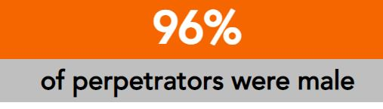
Progressive Alliance of Henderson County has several postcards that are appropriate to highlight our concern about gun violence. Please go to our website and use the Contact US button to order postcards. You are welcome to choose several themes or all of one style.

