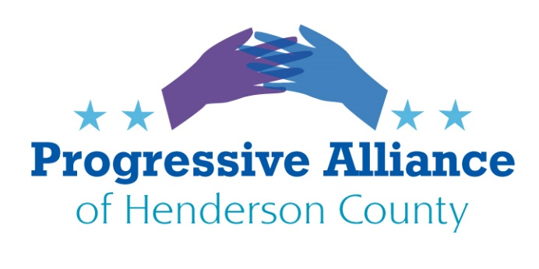

Postcard Party # 148 Nov. 22, 2019

Please note: Please continue to write concisely and in a civil but direct tone. The civil tone can be most productive in communicating with local officials who apparently personally read our postcards, whereas the federal officials generally just count numbers for and against specific legislation or issues.

National

THE VIOLENCE AGAINST WOMEN ACT: H.R. 1585: Violence Against Women Reauthorization Act of 2019
The Senate has not taken up H.R. 1585 to reauthorize the Violence Against Women Act that was previously supported by both Democrats and Republicans.
Action: Contact Senators Thom Tillis and Richard Burr to tell them to work with Democratic Senators to go around Majority Leader McConnell to force a vote on the Violence Against Women Reauthorization Act of 2019.

THE DESIGN AND FUNDING FOR A NATIONAL INFRASTRUCTURE ACT: H.R.4780 - National Infrastructure Investment Corporation Act of 2019
Last month Rep. Carbajal of California introduced the National Infrastructure Investment Corporation Act of 2019. This is a first step to design and fund repair of our critically damaged and decaying infrastructure throughout the nation.
Action: Contact Senators Thom Tillis and Richard Burr and Rep. Meadows. Ask them each to work with their Democratic colleagues to design and fund a robust program to repair our unsustainable infrastructure, through a public program and not through bogus “public/private partnerships” that give private entities control over and profits from invaluable infrastructure utilized by all people in the U.S..

COMMON SENSE GUN SAFETY LEGISLATION: H.R. 8: Bipartisan Background Checks Act of 2019
The House of Representatives has already passed necessary and sensible background checks legislation.
Action: Contact Senators Thom Tillis and Richard Burr to tell them to work with Democratic Senators to go around Majority Leader McConnell to force a vote on the Bipartisan Background Checks Act of 2019.

THE AMERICAN PEOPLE DESERVE A FUNCTIONAL CONGRESS THAT PASSES A BIPARTISAN BUDGET, WHICH DOES NOT FUND AN UNNECESSARY AND DYSFUNCTIONAL BORDER WALL.
This week Congress will pass another Continuing Resolution to fund the federal government for another month. The major stumbling block to passing a budget that addresses concerns of Democrats and Republicans is Pres. Trump’s continued demands to provide $5 billion or more for his useless border wall, as promised in his 2016 campaign.
Action: Contact Senators Richard Burr and Thom Tillis and Representative Mark Meadows to tell them to support a budget compromise for Fiscal Year 2020 that does not include the useless border wall.

State
MEDICAID TRANSFORMATION AND MEDICAID EXPANSION
The steps to sustainably transform Medicaid in North Carolina and to expand Medicaid in accordance with the Affordable Care Act are trapped in gridlock.
Action: Contact Sen. Chuck Edwards, Rep. Chuck McGrady, and Gov. Roy Cooper to tell each of them to work with the other two to find a pathway to sustain regular Medicaid and to accept Medicaid expansion through the Affordable Care Act.

LEGISLATIVE ACTION IN NORTH CAROLINA AGAINST GUN VIOLENCE IS STALLED. LEGISLATIVE ACTION IN NORTH CAROLINA TO FURTHER REDUCE GUN SAFETY MEASURES IS ALSO STALLED.
There is reportedly little prospect that any action on gun violence or on undermining gun safety is stalled in the General Assembly. 2020 is an election year and strange, unfortunate things can suddenly happen. On the other hand, several gun safety bills could possibly be attached to a final budget bill.
Action: Contact Sen. Chuck Edwards and Rep. Chuck McGrady to tell them we want them to support HB 508 (safe firearm storage education funding) and HB 454 (Extreme Risk Protection Orders) whenever there is any opportunity to move them in 2020 and to oppose legislation to arm teachers, weaken concealed carry requirements, or repeal the pistol purchase permitting system in 2020.

