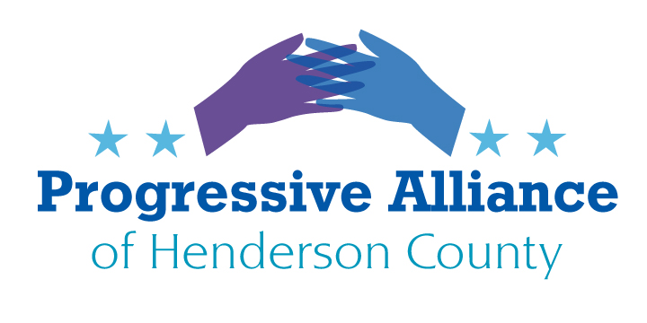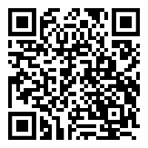
Progressive Alliance Post Card Party Suggestion Sheet # 218
(IT’S ALL ABOUT NC)

To Hide or Not to Hide—Information, that is the Question
SB 355 is a bill filed in the North Carolina Senate that, if passed, would result in the strongest improvement in decades in the people’s ‘right to know’ in our state. 35 states have enacted policy to allow the public access to personnel records of public officials and employees. There is pushback from educators and state employees on the passage of this bill. Why, what do they have to hide? Let’s face it, why shouldn’t the public know if state employees have been felons, or have been fired in another state or been cited for criminal behavior? This is a “Right to Know” transparency bill. We elect a portion of these officials but others across the state are just hired. As we have read and seen in the last four years, officials have become criminals in the public eye and are escaping prosecution. Is that what we want for our state? If you agree, then support this bill by contacting your Senate State Reps at:

Senate Members 2021-2022 Session - North Carolina ...
https://www.ncleg.gov ›

Another Transparency Issue—SB 636 Non-Profits and Dark Money
It’s already done. The Republican-led NC Senate voted to prevent disclosure of contributors to nonprofits, prohibiting legislators and government workers from disclosing confidential information. It would instead give nonprofits the final say in whether a donor's public information can be released. But there is still an issue and it is not too late to voice your opinion as the bill now goes to the NC House Committee on Rules and Operations.
This is about Dark Money in North Carolina. Opponents of the bill say the law could shield political organizations from campaign finance regulations. Non-Profit, Dark Money, Really? Yes.
Some nonprofits exist primarily as "dark money" groups, spending part of what they collect on issue advertising that figures heavily into political races. Often, these groups give to each other, moving money around until it's difficult to determine what came from where. They launder the money and then spend it on behalf of the donor.
This issue is now before the Supreme Court. It was initially brought to light in CA. It is not too late to contact your NC State Congressional Reps to ask them to vote against allowing non-profits to function as a political arm and cash cow for their donors’ voter privileges. Again, we need transparency into the money that is funding our legislators.
North Carolina House Representatives: https://www.ncleg.gov/Members/MemberList/H

OTHER NC General Assembly Bills to Address with our Legislators:
Attacking Reproductive Healthcare
Republicans in the NC House and Senate have fast-tracked two outrageous anti-abortion bills: Senate Bill 405, the “Born-Alive Abortion Survivors Protection Act,” which is a slightly amended version of a bill vetoed in 2019 by Gov. Cooper, and House Bill 453, the “Human Life Nondiscrimination Act/No Eugenics” bill, which would prevent someone from getting an abortion based on the race of the fetus or a fetal diagnosis of Down syndrome. The "nondiscrimination" and "eugenics" language is particularly insulting, given the state's not-too-distant history of sterilizing women of color against their will. SB 405 is expected to pass both chambers and again face a veto from the Governor, which Republicans don't have the votes to overturn
Attacking Voting Rights
Also included in the current frenzy is anti-voter House Bill 782, the so-called “Elections Certainty Act.” This bill eliminates a long-standing provision that protects absentee voters from mail delays. If this bill were to pass, absentee ballots that are voted by Election Day but received after 5 pm on Election Day would be null and void. If this bill had been in effect in 2020, over 11,000 mail-in ballots in North Carolina would have been tossed out, which is a decisive number in tight races.
Attacking Our Right to Protest
Last Tuesday the NC House passed House Bill 805, the "Prevent Rioting and Civil Disorder" act, whose lead sponsor was House Speaker Tim Moore. The effect of this bill would be to stifle free speech and the right of protesters peaceably to assemble, by imposing harsh criminal penalties on any protesters charged with "rioting." HB 805 is one of more than 90 anti-protest bills being pushed by Republicans in state legislatures across the country.
Attacking Discussion of Race in the Classroom
On top of everything else, the NC House passed controversial House Bill 324, "Ensuring Dignity and Nondiscrimination," which restricts what NC school children can be taught about our country's racial history. HB 324 is one of many bills being pushed by Republican legislators across the county trying to whitewash history in the classroom.
(Courtesy: Indivisible Asheville)
North Carolina House Representatives: https://www.ncleg.gov/Members/MemberList/H

