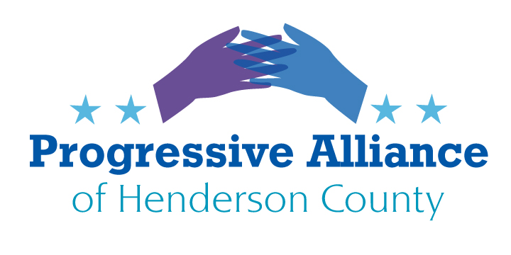
Virtual Post Card Party #238 April 1, 2022
Welcome to the April Fools’ Day edition of the Sheets of Suggestions. No need to take any of these ideas too seriously. Or maybe you’ll find that the ideas are more than idle and far-fetched jokes. Decide for yourselves.
Please date your messages April 1, in case a recipient may tend to not recognize a spoof or have a sense of humor.
(One might expect this sheet to take a pass on commenting on/contacting Mad Cawthorn. Just too easy to see foolishness in his every action. But, hey, let’s not bypass the opportunity as we expand the repertoire of how to support our “Congressman’s” ongoing education.)
APPLICATION FOR ADVANCED EDUCATION
Dear Rep. Cawthorn,
It seems that Cirq-U, North Carolina’s very own clown school, is eagerly awaiting your application for their next semester. This is an unparalleled opportunity for you to achieve a credential, even if only a certificate, that has escaped you in your brief undisciplined life, bedeviled by ignorance. Inside and outside the Congress you have shown an exceptional ability to reach for absurd effects, which augurs well for your future career as a professional clown. With respect, your current constituent, hoping you find satisfaction and purpose in your post-Congress life.
Just go online at https://www.cirq-u.com/ . There’s even a Homeschooling class although, given the poor results from your earlier education, perhaps it’s best to choose an on-site course.
¿QUIEN ES MÁS MACHO?
To Rep. Cawthorn’s staff (especially Luke Ball):
It has come to my attention that Rep. Cawthorn’s staff has sought to build up the masculinity of yourselves and your young man. I recommend that you study up on what makes a man a man (and a woman a woman) by viewing the relevant videos and modeling yourselves on such a great exemplar as Ricardo Montalban. (No, no, he was not an undocumented immigrant.) Then you will undoubtedly decide to serve our great country in another line of work.
https://vimeo.com/365899455
https://www.youtube.com/watch?v=k71241JN3OM
https://www.youtube.com/watch?v=P2CmXYuCGRw

FUTURE LEADING “SMART-ALEC” LEADER OF NORTH CAROLINA
It has been so exciting to follow your unstoppable career as the leading representative of a return to the 16th Century. You’ve done so much to drag North Carolina back to freedom for the holy and pure, while the rest are constitutionally required to obey God-ordained man’s men like yourself. Now you are on the cusp of carrying on Chuckie Edwards’ ALEC leadership into the NC Senate. Undoubtedly your manliness will force our great state to reverse all the rights and liberties that the undeserving have stolen these past 60 years. Please make it well known on social media and the lamestream media that you will target “gay marriage”, interracial “marriage”, “critical fluid gender theory”, and the rest of the Woke heresy once OUR U.S. Supreme Court declares Roe v. Wade is no longer the law of the land. So much yet to accomplish. Just imagine, Governor Moffitt!
https://www.timmoffitt.com/
Tim.Moffitt@ncleg.gov

THANK YOU JUSTICE THOMAS FOR RESIGNING AT THIS DIFFICULT TIME
Hon. Justice Clarence Thomas:
Thank you for your courageous resignation. I appreciate that you have pulled the plug on the Woke lamestream media, depriving them of a punching bag by not enduring repeated calls for you to recuse yourself from critical cases on which you should actually be the decisive vote and the author of decisions that restore the original meaning and intent of our Constitution (while recognizing that the 13th, 14th, and 15th Amendments were aberrant and improperly ratified departures from the Founders’ intentions). Please give your marvelous partner Ginni my fondest regards, and convey to her my hope that she has now been liberated to fully sweep away the lies and corruption of the communistic Democrat Party.
Most sincerely,
A Jan. 6 patriot, not yet snared by the Gazpacho Department of Injustice.
Hon. Justice Clarence Thomas
Supreme Court of the United States
1 First Street, NE
Washington, DC 20543
Telephone: 202-479-3000
TTY: 202-479-3472
https://www.supremecourt.gov/contact/contact_pio.aspx

