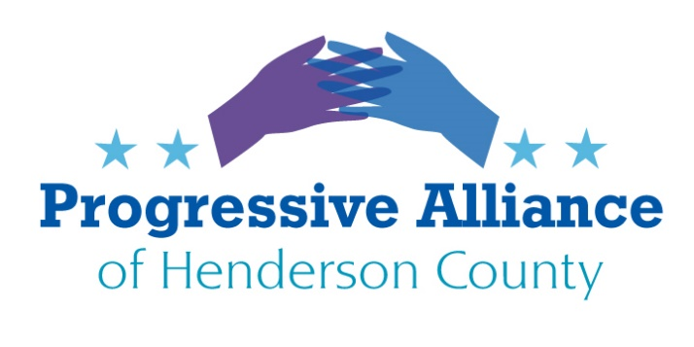
POSTCARD PARTY VIRTUAL #184 July 31, 2020

SUPPORT THE UNION ORGANIZING FIGHT BY REGISTERED NURSES AT MISSION HOSPITAL IN ASHEVILLE

Registered Nurses (RNs) at mega-hospital company HCA Healthcare’s Mission Hospital in Asheville have been organizing for many months to obtain a National Labor Relations Board election on whether nurses there shall be represented by a union.

Per the Asheville Citizen Times: “On March 6, 1,600 registered nurses petitioned the National Labor Relations Board (NLRB) to form a union, a massive organizing push in the country’s second-least unionized state. Whether the crowd gathering two days later at Pack Square Park knew it or not, they were kick starting one of the largest union campaigns in the country today. While an election date remains unset, labor advocates and experts say a union win of this size could spur further labor organizing across North Carolina.”

From Facing South: “In an Intercept article published in May, Matthew Cunningham-Cook and [Jonathan Michels] revealed how HCA Healthcare used the coronavirus pandemic to delay a union election at the same time the corporation stood to amass $4.7 billion in federal aid relief. While Mission nurses braced for an onslaught of COVID-19 patients, HCA Healthcare continued to send in union busters making $400 per hour to pull the workers off of their units for one-on-one meetings in an effort to turn them against the union.”

Asheville Mayor Esther Manheimer published a letter supporting Mission RNs’ exploration of unionization:
https://www.scribd.com/document/450646063/Manheimer-Newman-statement-on-Mission-nurses-exploration-of-unionization#from_embed

Contact the local Mission Hospital CEO and the national company’s CEO to tell them to get out of the way of union organizing at “their” facilities. Tell them that “Heroes Work Here” is mere opportunistic and hypocritical propaganda to cover up their near limitless willingness to exploit and drain the hospital workforce they are fortunate to have working at Mission Hospital.
Contact any of our politicians and candidates (Cooper, Burr, Tillis, Edwards, McGrady) to tell them to sign on to Asheville Mayor Manheimer’s letter endorsing the NNU’s drive to organize Mission Hospital’s RNs.
Contact the national office of National Nurses United to tell them you support their efforts and that you would like to know how to help them, if feasible. If you wish, please ask that NNU forward your message to the local organizer and/or one of the three RNs listed below who have been quoted in news articles as supporters of the union organizing drive.

National Nurses United [national office] Chad Patrick, CEO
8455 Colesville Rd, Suite 1100 Mission Hospital/HCA Healthcare
Silver Spring, MD 20910 509 Biltmore Ave.
Attn: Trish Stevenson Asheville, NC 28801
Or
Attn: Kelley Tyler Samuel N. Hazen, CEO
Or HCA Healthcare
Attn: Jill Rabideau One Park Plaza
Nashville, TN 37203

OTHER CAMPAIGNS ONE CAN WORK ON:
CAMPAIGN ZERO
Contact Campaign Zero at https://www.joincampaignzero.org/ to learn more about working toward ending police violence in America.
ERA-NC ALLIANCE Action Alert
The U.S. House of Representatives passed HR 79 to remove the arbitrary time limit for ratification of the Equal Rights Amendment on February 13, 2020.
We have moved to the Senate. NOW is the time for you to contact Senators Thom Tillis, Richard Burr, and Mitch McConnell, Majority Leader. These Senators have not yet indicated their support, and this is national legislation that impacts us all:
Dear Sen. :
“Please vote ‘yes' to remove the time limit to ratify the Equal Rights Amendment by co-sponsoring and passing SJR 6. I strongly support equal rights for all and appreciate your voting 'yes' to drop the time limit. Thank you so much!!"
Also, please reach out to individual friends/relatives across the country and encourage them to contact their senators!
In addition to social online messaging, you can contact these Senators as below:
Senator Thom Tillis  113 Dirksen Senate Office Bldg. Washington DC 20510  Phone: (202) 224-6342  www.tillis.senate.gov/email-me | Senator Richard Burr  217 Russell Senate Office Building Washington, DC 20510  Phone: (202) 224-3154  www.burr.senate.gov/contact/email | Senator Mitch McConnell  317 Russell Senate Office Building Washington, DC 20510  Phone: (202) 224-2541  www.mcconnell.senate.gov/public/index.cfm/contactform

EAST FLAT ROCK ASPHALT DRUM PLANT
Please go to friendsofeastflatrock.org for more information and to lend support to their efforts to stop the rezoning for an asphalt drum plant.
https://friendsofeastflatrock.org/

