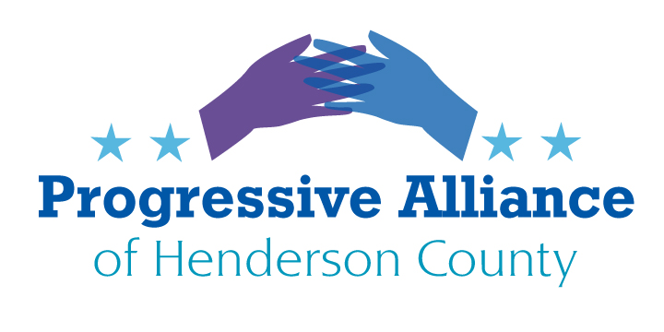
Virtual Post Card Party # 242 June 5, 2022
The Biannual Short Session of NC Legislature

Medicaid Expansion
The state Senate has adopted, 44-1, HB 149, to expand Medicaid; under the current laws approximately 90% of the typically State funded share is to be paid from Federal accounts. Most remaining costs are to be paid by hospitals (that is, costs are shifted to other accounts paying hospitals). This new coverage offer would newly insure several hundred thousand North Carolinians for medical costs if passed by the NC House. We urge all to write Rep. Moffitt (P.O. Box 768, Hendersonville 28793) or Rep. Jake Johnson (300 N. Salisbury St, Room 306B1, Raleigh 27603-5925) to urge Speaker Tim Moore to take up this Expansion Bill in the current Short Session. Moore says he does not want to take up such complex legislation on a tight schedule. But the main ideas have been in circulation since 2013. If Moore has concerns, he can ask a study committee be set up to report in January 2023. Meanwhile, thousands of people will get medical care that would otherwise likely go without.

Shiny Object Warning: Parents Bill of Rights
The state Senate has passed a revived bill from the House, HB 755. It needs to be reconciled to a differently-titled House version. In now contains many shiny objects: Ten enumerated parents’ rights regarding their children’s education, including roles long accepted, but also adding a right to review their child’s medical records in most cases, and a veto on biometric data collection (we hope that doesn’t include height and weight), and taking blood or DNA samples; making video or voice recordings of children in some cases; a report to parents of suspected crimes against children, barring law enforcement or child welfare investigations underway. Also, it establishes eleven legal rights of parents regarding kids’ education, such as reviewing records of borrowing from a school library; access to promotion or retention policies; inspecting texts and supplementary materials; to seek medical or religious exemption from vaccinations; to withhold consent of exposure to reproductive health and safety programs. These new rights are to be publicized by public schools.
The State Board of Education is to develop standards for local public schools to issue: Parents’ guides to student achievement, covering nine components, to be discussed among teachers, parents and students; to develop policies to involve parents, including coverage of six purposes including review of material related to reproductive health and safety programs; to set up a request-for-materials process for parents, with deadlines specified and right of appeal, including requirement to put appeals on school board agendas; and detailed notices to parents of any health care service and consent/veto opportunity; review of any change to a student’s name or pronouns in school usage or records; and many other new intervention opportunities.
All these detailed stipulations are polar opposite to many legislators’ stated goals, such as ‘limited government’ or rejection/fear of ‘I’m from the government and I’m here to help you’. Why? In part, this stuff is to serve up culture war issues, in part it’s to justify their contempt for public education – by creating rigid public school rules so that charter or private schools get to look better. Ask Representatives Tim Moffitt and Jake Johnson to oppose House concurrence to Senate amendments to H. 755, Parents Bill of Rights.

