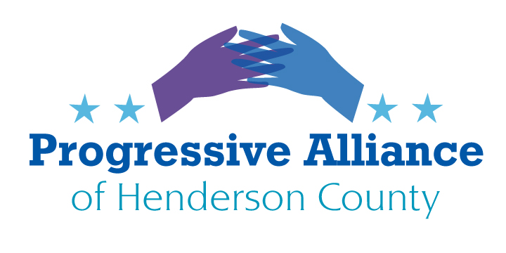

Postcard Party 231 December 15, 2021

NC State Education Lottery System New Legislative Bill
Write our State senators. Edwards and Corbin have introduced Senate Bill 376 which addresses the inequity of the NC State Educational Lottery system. This was brought to their attention by the WLOS investigation that Kim King reported on in September when our very own Vikki Schantz introduced the story to her. They are pushing for 40% of the lottery proceeds as it was originally when it was set up, instead of the 24% they get now. They are also asking to get rid of the Tier system which prevents schools from receiving funds based on Regional economics.
The ongoing issue is North Carolina is using the lottery funds in place of tax dollars for education rather than as a supplement.

Quit killing whales, porpoises, and dolphins.
These three countries still kill whales:

Ambassador Shinsuke Sugiyama
Embassy of Japan
2520 Massachusetts Ave. NW
Washington DC 20008

Ambassador Geir Haarde
Embassy of Iceland
1156 15th St. NW
Washington, DC 20005

Ambassador Anniken Krutnes
Embassy of Norway
2720 34th St. NW
Washington DC 20008

Weapons Manufacturing
- Write Congress to quit authorizing so much money for weapons manufacturing, that we are too willing to sell our excess overseas. The military industrial complex is a huge contributor to their “campaigns”, stop taking this money.
- Write Congress to stop manufacturing and using land mines. Join the 160 countries that signed the 1997 Mine Ban Treaty.
- Write Congress to stop giving weapons of war to local police.

Broadband
Write NC General Assembly to allow municipalities to build and operate broadband as a public service with access for all. The following law passed, but keep up the pressure.
tps://www.ncleg.gov/Sessions/2019/Bills/Senate/PDF/S769v1.pdf

Voting
Write NC General Assembly to make photo id voter cards easy to get and free.

Immigration
Write Congress to finalize a fair DACA policy for Dreamers.

NRA
Write Secretary Janet Yellen, Department of the Treasury to remove any non-profit status from the NRA.

Cuba
Write Congress to reopen Cuba. The embargo enriched the elite and devastated the rest.

Cawthorn
Write Henderson Co. Sheriff Griffin and Fletcher Police Chief Daniel Terry that Cawthorn is not above the law. Carrying weapons in a school environment is a misdemeanor. Charge him.
Chief Daniel Terry
300 Old Cane Creek Rd.
Fletcher, NC 28732

Constitutional Duties
Write Congress that it is not fulfilling its constitutional duties by not bringing laws forward. Blame McConnell

Term Limits
Write our state legislators to start an amendment to limit terms for Congress. The original intention of the Constitution was that serving was a higher calling not a perpetual well-paying job.

