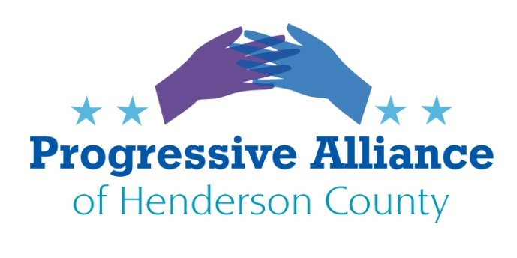

POSTCARD PARTY #146 NOVEMBER 8, 2019

CITIZENS CLIMATE LOBBY in partnership with the PROGRESSIVE ALLIANCE OF HENDERSON COUNTY

We are supporting CCL in their effort to garner support for HR 763, the Energy Innovation and Carbon Dividend Act. The postcards provided by CCL will be picked up at the end of today's postcard party and hand delivered on Tuesday in Washington.
Suggestion: use return address labels as an easy way to prove you are a constituent.

Let’s get behind Climate talks!

A Bipartisan Climate Solution that will Help Grow our Economy and Innovation
Citizens’ Climate Lobby (CCL) www.citizensclimatelobby.org believes that politicians don’t create political will, they respond to it! CCL is a non-partisan international grassroots advocacy organization that works to bring both sides of the aisle together on a bipartisan federal climate solution called Carbon Fee & Dividend that is economically viable. They have been successful at getting federal climate policy implemented in Canada, and getting the first federal climate bipartisan legislation introduced into the U.S. House of Representatives: the Energy Innovation and Carbon Dividend Act www.energyinnovationact.org.

CCL will explain how their proposed solution is the strongest, most comprehensive legislation to reduce carbon emissions at the scale and speed that is necessary to almost meet the IPCC goals; how it will help to grow our economy, jobs, and GDP; and why virtually all top economists agree that this approach is the most effective way to stabilize the climate, grow American jobs, spark innovation, and bolster national security. Learn how to get involved and why this bipartisan market-based climate solution is something we can all get behind, regardless of partisan politics. Climate change can be a bridge issue, NOT a wedge issue!

Steffi Rausch is lead organizer for the Asheville Citizens’ Climate Lobby as well as owner of Evolv (www.evolv.com), a local web design & development company.

Steffi Rausch
Asheville Lead Organizer for Citizens’ Climate Lobby
828-242-3752
asheville@citizensclimatelobby.org
www.citizensclimatelobby.org
www.facebook.com/ashevilleccl

