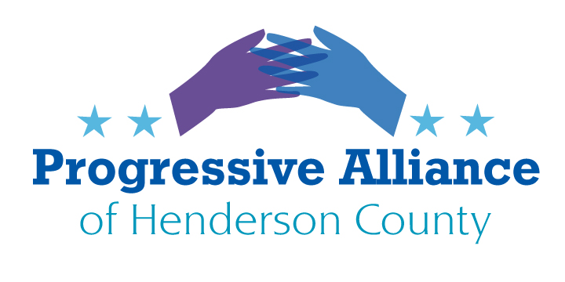
Post Card Suggestions Oct. 16, 2020
30, 30, 30
It is emblematic of today’s America that many people are resentful and opposed to production line workers in the US being unionized and making $30+ per hour wages, including benefits, such as health care and retirement. However, many are not concerned that banks charge 30+% for credit card debt (while they pay less than 1% interest to customers who lend them money in the form of checking and savings accounts) and CEO’s of unfamiliar “public” corporations make $30+ million in compensation each year. The numbers show the production line worker earning 2 tenths of one percent (.2%) of the CEO’s pay, even though they might work for the same corporation and both are merely employees of said corporation.
Over the last 40 years the Republicans and big business and money interests have done a wonderful job of denigrating the idea of labor unions and the benefits they have for their members and our society as well. The image of the overpaid, lackluster, short hour union member has been so well presented that mention the word ‘union’ to many average Americans and the knee-jerk reaction will be the same as to the words ‘liberal’ or ‘socialist.’
This denigration has run parallel to the rise in corporate executive pay, banking boom (and bust) and the stagnation and subsequent contraction of the American middle class. There has been a steady rise in the normalization of both trends.
Write Congress about the weakening of the middle class and the need for labor unions.
The Court and the Constitution
The President (‘he who must not be named’) praised his latest Supreme Court nominee Amy Coney Barrett’s “unyielding loyalty to the Constitution.” So, she is to join the other conservative judges who are supposedly strictly adherent to the words and intent of the founding fathers. If so, how do we interpret the Supreme Court’s conservatives ruling over the last 10 years for agreeing that corporations are like people, legally, through the Citizens United ruling of 2010. This ruling overturned the long-held practice of the allowance of political contributions by groups and corporations being governed by the consequences of doing so, not by the idea of “freedom of speech” through unfettered money in politics.
It would seem pretty clear that the founding fathers never intended that whoever has and spends the most money will rule the day.
Judge Barrett was nominated to the U.S. Court of Appeals for the Seventh District in 2017 by the current president. This followed a career as an academic for 15 years at Notre Dame, her law school alma mater. Previously, she was a Supreme Court clerk followed by 2 years at a law firm.
In short, her experience for the job of Supreme Court nominee is pretty thin. There is no Supreme Court nominee in modern times who brought such limited experience to the job. Her nomination seems to be centered solely around her political philosophy of opposition to abortion. In 2006, she signed an open letter to the South Bend Tribune (Indiana) declaring, “It’s time to put an end to the barbaric legacy of Roe v. Wade and restore laws that protect unborn children.”
As we can hear from her testimony before the Senate Judiciary Committee, Judge Barret has refused to answer any questions about her views, hiding behind judicial neutrality doctrines. The Democrats ask reasonable questions and the Republicans throw Judge Barrett soft balls and make speeches about how disreputable the Democrats are.
Who says that the court must only have 9 justices? Not the Constitution. Briefly, the Constitution mandated that there be a Supreme Court and the Congress should set up the state courts under it. At first, there were 6 justices, which became 5, then 7, then 10, etc.; but you get the picture. It changed continually up until the 20th Century when it settled on 9. Obviously, the country has grown enormously in both size, population and importance in the world since its founding in the 18th Century. Along with many other things, like the number of Senators from Rhode Island v. California and the Electoral College, our country’s evolution and representation has remained stuck in the past. Are we represented as well as we should be in a democracy? That is open to question and should be debated amongst reasonable people. Are there enough left to have a real conversation?
Write the Supreme Court and Congress to let your voice be heard in addressing these issues.
Our Future Beyond trump
A wise person once suggested that planning through an anticipated outcome or conclusion is a good way to keep enthusiasm alive and avoid a finish-line deflation. It doesn’t seem too optimistic to think about future goals once trump is neutered and out of the way.
What about our tax code? The revelations of trump’s tax returns shine a bright light on the disparities between the rich and the rest of us, and especially the poor. Since Reagan’s days it has been one of the main goals of the wealthy to gut the Internal Revenue Service. This is an all too obvious strategy for them to pay less taxes, and it has worked. Fewer agents, fewer audits, less taxes collected from the wealthiest Americans. However, there are other familiar goals which have been realized.
According to the NY Times, the five counties with the highest audit rates in the country are all predominately African American counties in the South. An example is Humphries County in rural Mississippi where the median annual family income is $28,500. One third of the population lives below the poverty line. The government targets audits on poor families who use the earned income tax credit, an anti-poverty program. This is while billionaires claim enormous tax deductions for donating expensive art to their own private “museums” located on their own property!
What a great country this is!
Write Congress and the new President and demand fair tax codes where the rich pay their fair share, and the poor are not targeted.
North Carolina Liquor Sales. State Rep. Chuck McGrady, now retired from the NC General Assembly, pushed for the privatization of the liquor sales in N.C., ending the monopoly of the states’ ABC stores. This is a complex issue, but certainly not one that is without other viable examples in other states. Briefly, ABC buys spirits, other than beer and wine, from wholesale distributors. The only way an individual or even a restaurant or bar to buy a bottle of liquor is through ABC, which has a warehouse and distribution system.
The push to privatize liquor sales presents a number of differing views. First, it is a change to an established system. Some people do not want change. Jobs would be lost within the ABC system as retail outlets would replace ABC stores. Some religious organizations object to more sales outlets believing it will increase alcohol sales and therefore promote alcohol abuse. Others believe that prices for liquor would increase with the new, private middlemen and retailer’s profits to consider. Local and state revenues might fall which would impact community budgets that depend partly on alcohol sales. Etc.
In short, there are many questions to be answered and details to work out in any compromise, if a change is indeed coming. Depending on how you feel about this issue write to your local and state representatives voicing your concerns and questions.
Question Time or Don’t look under the rug?
Thankfully, many members of Congress are actively concerned and working toward answers to difficult current questions as well as those from our recent past. Rep. David Price of the 4th District of NC (Raleigh-Durham) is pursuing answers to the difficult questions raised about the CIA’s Rendition, Detention and Interrogation program following 9/11.
Rep. Price is asking the CIA Director, Gina Haspel, for detailed information on the activities of the CIA and private contractors involved in the rendition program and specifically the evidently illegal use of NC public infrastructure and private citizens during the transportation and detention of prisoners.
For more information and to thank Rep. Price for his work, write:
David E. Price
United States House of Representatives
NC 4th District
1777 Fordham Blvd.
Suite 204
Chapel Hill, NC 27514

