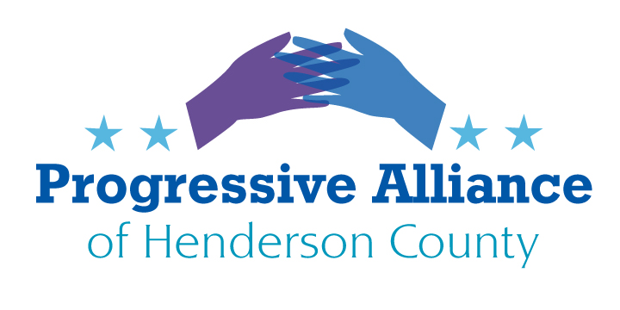
Virtual Post Card Party #219 June 15, 2021

WORKING PEOPLE 1: SUPPLEMENTAL UNEMPLOYMENT INSURANCE
ABC11 – Raleigh: North Carolina's unemployed would no longer receive the pandemic-related $300-a-week federal unemployment supplement under legislation approved by a state House committee [on June 2]. The measure would withdraw North Carolina from the Federal Pandemic Unemployment Compensation program, joining two dozen other states that have done the same thing. The proposal would eliminate these extra benefits 30 days after the bill became law. The program already is scheduled to expire nationwide in early September.
Long before 2016 the Republican Party pretended/intended to become the leading party of the white working class through a politics of class and race grievance and through the rejection of Democratic elites that allegedly denigrate working class people and values.
What has the Republican Party actually done for working class people lately? In 2020 Democrats joined Republicans to pass bipartisan economic relief for all Americans to get through the pandemic. But when Pres. Biden took office the Republicans voted as a bloc against the American Rescue Plan. Now Republicans in numerous states are successfully cutting back what they can from that plan.
There is no question that there is an imbalance in the labor market---except that we are actually experiencing imbalances of various kinds in a greatly changing economy, changes that are not explained by simplistic Republican anti-worker claims that lazy people are eating bonbons with their supplemental unemployment benefits and refusing to meekly troop back to low paying restaurant and other service jobs. In fact, our country is experiencing a wage crisis and overall not a labor shortage.
The workers who once were essential and therefore heroes are now worth perhaps less than ever. Now that an imbalance tends to favor workers in seeking higher (if not quite living) wages and above minimal benefits, the Republican majority in the NC General Assembly wants to cut them off at the knees as soon as possible, all without increasing the state’s minimum wage or expanding Medicaid. The very thought that working people might be in a stronger than usual position to negotiate for adequate wages gives Republicans the willies.
Write to NC Sen. Edwards and NC Assembly Members Moffitt and Johnson to tell them to stop blaming NC workers for the difficulties the pandemic brought us and which are quite simply not over yet.
WORKING PEOPLE 2: GOING TO WORK LIKE YOUR CONSTITUENTS
As a corollary to the first item, let us now ask whether our state legislators, our Governor, our member of the House of Representatives, and our two U.S. Senators know (or care) “how the other half lives” (or, actually, how the 60% to 90% live, depending how one defines income and wealth levels in the United States).
A modest proposal: in a staggered fashion over the next 6 months, all of our elected officials should take the time to live like their most humble constituents. A) Take a 4 week leave of absence. B) Take a regular low-paying essential worker job for 4 weeks. C) Take all of your household’s normal income for those 4 weeks and put it in trust for a donation to a local food bank. D) Have your household live for those 4 weeks on just the money from your regular low-paying essential worker job. E) Ask your supervisors to treat you just like they normally treat their employees, no better and no worse.
After those 4 weeks answer a questionnaire (yet to be prepared) about how your experiences affect your policy approaches to minimum wage, working conditions, health insurance, union rights, child care resources, and so on.
Send this suggestion to any and all elected officials and in letters to the editor to our local and statewide media outlets.
PROTECT THE NC DEPARTMENT OF ENVIRONMENTAL QUALITY SO IT CAN PROTECT OUR ENVIRONMENT
NC Policy Watch: In a snub to Gov. Roy Cooper and an apparent affirmation of the political power of energy utilities, the Senate Agriculture, Energy and Environment Committee rejected the confirmation of Secretary of the Environment Dionne Delli-Gatti [June 2] during a tumultuous and heated hearing.
Write to NC Sen. Edwards and NC Assembly Members Moffitt and Johnson to remind them that the job of the Department of Environmental Quality is to protect and sustain “environmental quality” in our state, not to be playthings of energy utilities or any other special interest that makes huge campaign contributions. Such contributions, of course, cannot be gathered and distributed by NC’s streams, forests, wildlife, coasts, and so on.
DIDN’T THE 2020 ELECTION END THE MALIGN INFLUENCE OF THE WILLIAM BARR JUSTICE DEPARTMENT?
Attorney General Merrick Garland has undertaken many positive changes in the Department of Justice since he was selected by President Biden and confirmed by the U.S. Senate. But lately the DOJ has continued to press inappropriate federal cases that had been initiated by former Trump Attorney General William Barr:
Paul Butler in the Washington Post on 6/7/21: DOJ lawyers are fighting to keep secret a memo that Barr cited to justify his decision not to charge Trump with obstruction of justice during the investigation by special counsel Robert S. Mueller III. In another case, Justice lawyers suggested [in a court filing] that the gassing of lawful protesters by police last year in Washington’s Lafayette Square was appropriate for the safety of the president.
In addition, the DOJ has filed to substitute itself for former President Donald Trump as defendant in the defamation lawsuit E. Jean Carroll brought against the former president for his crude, disrespectful, and possibly false attacks against her. The DOJ argued in a brief on 6/7/21 that it should be permitted to continue the argument it had initiated under the previous administration even as the White House has changed hands. If the department had been allowed to intervene in the case that would likely have led to its dismissal, because the government cannot be sued for defamation.
Again, Paul Butler: One question that kept coming up during the presidential transition was how vigorously the new administration would pursue corruption investigations against people in the former administration. Now it seems the better question may be to what lengths the Justice Department will go to defend the Trump administration’s abuse of power — with its primary concern being preserving that power for the Biden administration and beyond. [Emphasis added.]
Write to Attorney General Merrick Garland, telling him that the Department of Justice should abandon its efforts to preserve the unbridled powers of the imperial presidency as they were conceived of by the former president and former Attorney General.
Hon. Merrick Garland
Attorney General of the United States
U.S. Department of Justice
950 Pennsylvania Avenue, NW
Washington, DC 20530-0001

