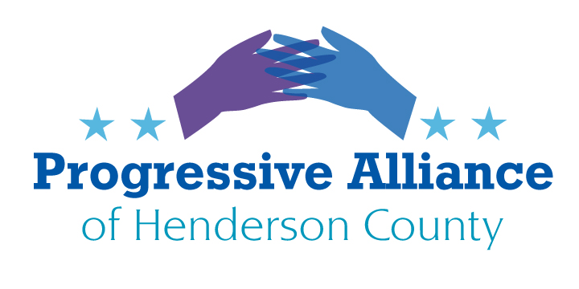
Post Card Party #257 January 20, 2023

WELCOME OUR NEW AND RETURNING NORTH CAROLINA LEGISLATORS

Here are a few suggestions of pithy statements that could be included on a postcard. There may be a few statements with which you agree, others with which you disagree, and any of them that you may rephrase to faithfully capture your perspectives and priorities.
Honorable ____________:
I’d like to welcome you to your role representing all of your constituents subsequent to the November 2022 election. In that spirit I look forward to an open-minded and serious conversation about:
A woman’s right to choose / Protecting reproductive freedoms at least as much as protecting Second Amendment freedoms / Keeping Christian nationalism from perverting religious tolerance and personal choices in North Carolina and America as a whole
Simplifying the U.S. federal income tax code / Retaining and strengthening the progressive nature of the federal income tax to make sure our wealthiest citizens are paying their fair share / Funding the Internal Revenue Service adequately (after years of politically motivated budget cuts) in order to effectively serve all taxpayers and provide due swift justice when high income earners fail to pay the tax they actually owe
Protecting our American democracy by making it easier to vote for all citizens throughout our country / Protecting our American democracy by vigorously rejecting false, unsubstantiated claims of widespread and numerous voting fraud / Protecting our American democracy by rejecting Christian nationalism and all insurrectionist militias that would destroy our freedoms and diversity
Seriously and effectively propelling North Carolina and all of America on the path to energy independence from fossil fuels / Seriously and effectively grappling with the national and international evidence of catastrophic extinction of species and continued alteration of the natural environment in ways that speed the dire results of the climate crisis
Making the true and vigorous agenda of North Carolina and our national government the recognition of human needs regarding housing, healthcare, public education, public safety, and a healthy environment so that special interests’ special pleadings and dishonest lobbying are rejected in favor of policies that help improve our society

Well, you get the idea. These statements are not the be-all and end-all of PAHC’s thoughtful and comprehensive advocacy. Please post your own suggestions on these and other topics on PAHC’s Facebook page. Undoubtedly we will revise our format beyond these start of session greetings to our legislators, perhaps eventually drafting mid-session or end-of-year report cards and so on.

