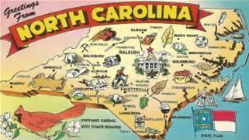

NC LEGISLATORS:

FEDERAL:

House of Representatives-Vacant
2160 Rayburn HOB
Washington, DC 20515

Senator Thom Tillis
185 Dirksen Senate Office Bldg
Washington, DC 20510

Senator Richard Burr
217 Russell Senate Office Bldg
Washington, DC 20510

STATE:

Governor Roy Cooper
20301 Mail Service Center
Raleigh, NC 27699-0301

Senator Chuck Edwards (District 48)
16 W Jones St, Room 2115
Raleigh, NC 27601

Representative Chuck McGrady (District 117)
300 N Salisbury St, Room 304
Raleigh, NC 27603

Representative Jake Johnson
(District 113)
300 N Salisbury St, Room 602
Raleigh, NC 27603

Hendersonville City Council:
145 5th Ave E
Hendersonville, NC 28792

- Barbara Volk- Mayor
- Ron Stephens- Mayor Pro Tem
- Jeff Miller
- Steve Caraker
- Jerry Smith

Henderson County Board of Commissioners:
1 Historic Courthouse Square, Suite 1
Hendersonville, NC 28792

- Grady Hawkins – Chairman
- Mike Edney
- William Lapsley
- Rebecca McCall
- Charlie Messer

Henderson County Sheriff’s Office:

Sheriff Lowell Griffin
100 North Grove Street
Hendersonville, NC 28792

FEDERAL:

THE WHITE HOUSE
1600 Pennsylvania Ave
Washington, DC 20500

