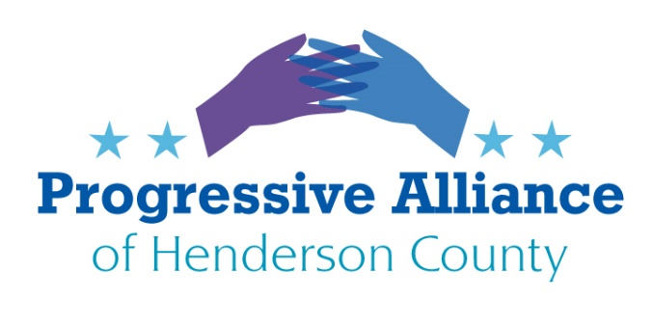

POSTCARD PARTY 176 June 5, 2020

Let’s write to anyone with responsibility about the changes you see needed in our public life.

NATIONAL

CALL FOR FEDERAL REFORMS
The Leadership Conference for Civil and Human Rights (founded 1950; over 200 nonprofit, fraternity/sorority, labor and advocacy organizational members) this week wrote Congress to meet with its members to enact reforms. About 400 other organizations have signed on. The federal reforms addressed in the letter include:
- Require a federal standard that use of force be reserved for only when necessary as a last resort after exhausting reasonable options, and incentivize states to implement this standard; require the use of de-escalation techniques, and the duty to intervene; ban the use of force as a punitive measure or means of retaliation against individuals who only verbally confront officers, or against individuals who pose a danger only to themselves; and require all officers to accurately report all uses of force;
- Prohibit all maneuvers that restrict the flow of blood or oxygen to the brain, including neck holds, chokeholds, and similar excessive force, deeming the use of such force a federal civil rights violation;
- Prohibit racial profiling with robust data collection on police-community encounters and law enforcement activities. Data should capture all demographic categories and be disaggregated;
- Eliminate federal programs that provide military equipment to law enforcement;
- Prohibit the use of no-knock warrants, especially for drug searches;
- Change the 18 U.S.C. Sec. 242 mens rea requirement from willfulness to recklessness, permitting prosecutors to successfully hold law enforcement accountable for the deprivation of civil rights and civil liberties;
- Develop a national public database that would cover all police agencies in the United States and its territories; and,
- End the qualified immunity doctrine that prevents police from being held legally accountable when they break the law.

If you agree that any or all of these requests demand Congressional leadership attention, please
write to Speaker Pelosi, Minority Leader McCarthy, Majority Leader Sen. McConnell, and Minority Leader Sen. Schumer.

More information: https://civilrights.org/resource/civil-rights-coalition-letter-on-federal-policing-priorities/
https://civilrights.org/2020/06/01/400-civil-rights-organizations-urge-congressional-action-on-police-violence/

STATE

ADAPTING THE 2020 ELECTION TO THE COVID EMERGENCY
Our State Senate has a bill filed to make many constructive temporary changes to adapt to the COVID crisis. Let’s ask Senator Chuck Edwards to get behind it:

NC Senate Bill 861, Election Protection During COVID-19 Emergency
- Appropriates $10.9M federal + $2.1M state to insure healthy polling places, fund absentee ballot access including return postage payment, compensating poll workers to insure an adequate staffing; Appropriates $11.6M federal (Help America Vote Act, HAVA) + $2.M state for cybersecurity, training and other costs, through June 2021
- Waive restriction of poll judges and assistants to only those resident in the precinct served, permitting use of students aged 16 or over to serve (if school is closed); permitting use of temporary staffing agencies to recruit workers; poll service not to restrict eligibility for unemployment benefits
- Supply poll workers PPE, enable curbside or drive-through balloting, enable social distancing at polls
- Election day as a paid state holiday
- Postponement of the Voter ID law implementation till after 2020 general election; allows usee of HAVA recognized documents to submit absentee ballot requests
- Change group home resident assistance team provision to allow trained home staff of more than one party to assist a resident to vote
- Change online voter registration to allow registrants to access their signature as recorded by a NC state agency
- Support for education efforts by Boards of Election to implement these changes

THANKS TO GOVERNOR COOPER
Write to Governor Roy Cooper for refusing to knuckle under to pressure form trump and his cabal, RNC. Our concern is with the many North Carolinians who would have been working for security, food services, cleaning services, etc. at the Convention Hall. And the many local hotels and restaurants serving the people attending the convention. Thank Governor Cooper for protecting North Carolinians, many who would be minorities.

LOCAL

LOCAL LAW ENFORCEMENT LEADER DESERVES OUR THANKS
Compliment Hendersonville Police Chief Herbert Blake for his Times-News column “Death of George Floyd ‘bad police work, lack of humanity’”
https://www.blueridgenow.com/news/20200531/column-hendersonville-police-chief-says-death-of-george-floyd-rsquobad-police-work-lack-of-humanityrsquo
Chief Herbert Blake
160 6th Ave. E.
Hendersonville, NC 2879

