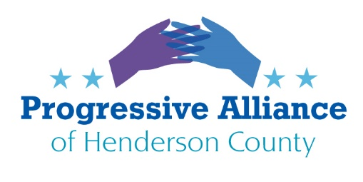
POSTCARD VIRTUAL PARTY #181 JULY 10, 2020
NOTE: If you need the most commonly used addresses, please see our home web page,
on the left column below OnGoing Events:
https://www.progressiveallianceofhendersoncounty.com/
Contact Information for people or institutions we do not have on our master lists will be listed in Each Topic
Let’s write to anyone with responsibility about the changes you see needed in our public life.
Last week’s issues that still may need additional attention:
- Target raises its minimum wage
- COVID-19 Business Bailouts
- Trump Doesn't Wanna Test for COVID-19 (from Washington Post June 21)
- Remove Traitors' Monuments from Old Courthouse
- 2020 Census Responses
- Local City Police
Monty Python's Flying Circus
MONDAY JULY 13TH 5:00 PM
Henderson County Board of Elections is holding a meeting on One-Stop Voting, which we all know as early voting. We need to have our voices hear about how important early voting is this year. Spreading out the days and the sites available makes a big difference in our health safety and better access for people who work, go to school or are in rural locations.
Instead of writing or calling, please attend this meeting. Wear a mask and bring your thoughts after reading:
https://democracync.org/take-action/elections-advocacy/
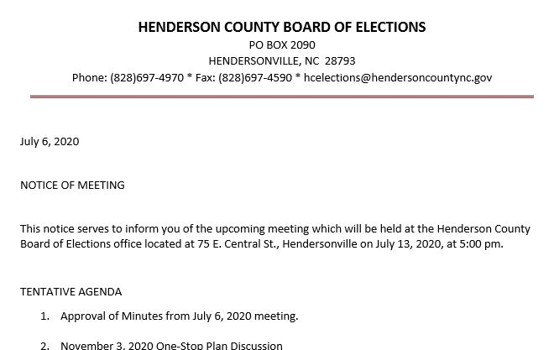
On our web site there are a year's worth of the prior Suggestion Sheets with many issues that still are not resolved. Please keep writing about the things that resonate with you.
We will Persist!
https://www.progressiveallianceofhendersoncounty.com/postcard-sheets

