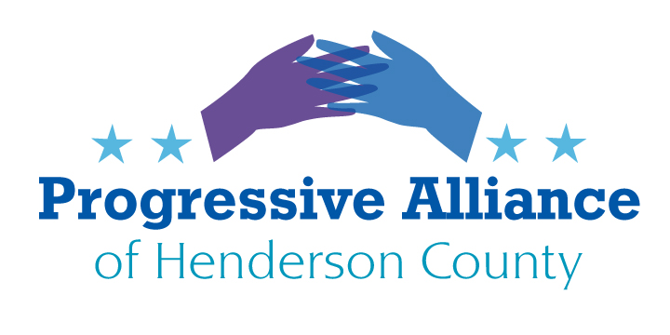

Postcard Party #232 January 1, 2022

In her daily political column issued on December 3, Heather Cox Richardson reported:

“Senate Republicans will not issue any sort of a platform before next year’s midterm elections. At a meeting of donors and lawmakers in mid-November, Senate Minority Leader Mitch McConnell (R-KY) said that the Republican Party’s 2024 nominee would be responsible for deciding on an agenda. The Republican senators in 2022 will simply attack the Democrats.”

No doubt, this will also be the game plan for House GOP candidates.

The party in power (tenuous as it may be) simple CANNOT retain it in 2022 if all we do in November’s elections is point to how bad it was during four years under the dictator-wannabee. It is all too easy to criticize, but the voters who control this fall’s elections will care about results, not finger pointing.

It is time to act like adults, and to govern.

Let’s start with these tasks for the first weekend in the new year:

1. Transmit at least three communications (phone, postcard, email) to your government officials, thanking them for having done a specific positive meaningful action in 2021. If you struggle to come up with said actions, try these:

Federal:

A. Thank non-GOP members of Congress for creating and passing additional stimulus relief for ordinary citizens.

B. Thank Democratic Senators for confirming 40+ progressive, diverse judges to lifetime appointments in Federal courts.

State:

A. Thank State Sen. Jeff Jackson for diplomatically dropping out of the Democratic race for U.S. Senate, saving the good guys from a divisive primary.

B. Thank Gov. Cooper for vetoing GOP-passed restrictions on voting accessibility and eligibility.

Local:

A. For either Henderson County or Hendersonville City officials, thanks for extensive efforts in soliciting citizens’ input to upcoming rewrites of the Comprehensive Plans.

2. Communicate with at least three government officials with a polite, positive request to create and exact a beneficial piece of legislation in 2022. Keep it upbeat, and keep repeating your pet issue(s) throughout communications in 2022. Here is the list from which this author will choose:

Federal:

A. Pass the Freedom to Vote Act

B. Pass the John Lewis Voting Rights Advancement Act

C. Create and pass legislation allowing Medicare to negotiate prescription prices.

D. Eliminate the filibuster, at least for voting rights issues.

E. Eliminate the Electoral College

State:

A. Create and pass an objective, non-partisan approach to redistricting.

B. Create and pass a vigilante-type assault weapons bill, modeled after the TX birth choice law.

C. Extend Medicaid eligibility to all NC citizens.

D. Allow NC municipalities to set higher minimum wage rates than exist state wide.

E. Shift the tax burden to those who can afford it and most benefit by tax-funded servicers, instead of to those who cannot afford to pay.

Local:

A. Create meaningful ordinances to restrict loss of tree canopies.

B. Increase funding for teachers and for core curriculum in civics, critical thinking and analysis, and STEM.

Wasn’t that easy? Don’t you feel better now?

Thanks for cooperating. Have a wonderful start to your 2022.

