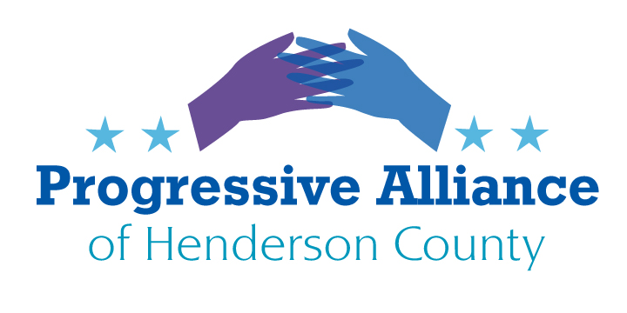
VIRTUAL POSTCARD PARTY #210 February 26, 2021

Issues from February 19, 2021 that may still need additional attention:

- Cawthorn…Again
- Voter Suppression
- Eliminating the Filibuster

THE PUBLIX SECTOR
Thinking outside the box: Julie Jenkins Fancelli is a super-wealthy heir to the founders of the Publix supermarket chain, which is present in Hendersonville and throughout the Southeast. Ms. Fancelli spent $300,000 to put on the Save America rally on 1/6/21, 60% of the total cost. She has been a loyal supporter of everything Trump, everything false and seditionist in the racist, violent America First movement.

Some folks have decided to boycott Publix, because it is now inextricably linked to the dilettante insurrectionist Ms. Fancelli. But the supermarket chain said in a statement, "Mrs. Fancelli is not an employee of Publix Super Markets, and is neither involved in our business operations, nor does she represent the company in any way." We should take them at their word, sort of. The company is employee-owned, which sounds good but merits more research.

Todd Jones is the CEO of Publix. His address is at 3300 Publix Corporate Pkwy, Lakeland, FL 33811. His email is todd.jones@publix.com . (The executive responsible for stores in North Carolina and neighboring states is kimberly.reynolds@publix.com .) Please write to Mr. Jones to tell him that the most appropriate way for Publix to constructively distance itself from Ms. Fancelli is to support pro-democracy organizations in the Southeast by contributing to them in an ongoing fashion TWICE the amount of all of Ms. Fancelli’s prior, current, and future violence-promoting spending. That will help the PAHC and the rest of the public feel confident that shopping at Publix is a good idea.

SUPPORTING THE AMERICAN RESCUE PLAN
and
A GREAT IDEA FROM A REPUBLICAN
The American Rescue Plan is making its way through Congress. The American economy needs this relief, meaning the vast underserved majority of the American people need this relief. So far all Republicans have rejected the bill in the House of Representatives. Yet huge majorities of ordinary Americans from all political persuasions support the bill’s provisions. The Congress has the too rare opportunity to pass major legislation that our people both need and want, benefiting the majority and not just the 1%. Perhaps a few Republican Senators will do the right thing rather than remaining knee-jerk obstructionists.

In fact, Sen. Mitt Romney proposed an ambitious plan for cash grants to parents, irrespective of the parent’s work status, that even goes beyond Pres. Biden’s similar proposal. Romney’s proposal would mean $1,050 a month for a single parent with three children under six, without penalizing the parent if she or he works. It’s a start towards eliminating child poverty. Democrats in the Senate should incorporate his proposal, even though Romney has signaled that he will vote against the American Rescue Act even if it includes his plan.

More details about the values of eliminating child poverty are found in this New York Times article:
‘There’s No Natural Dignity in Work’: Punishing mothers for needing help cannot be the answer. A generous child allowance might be.
https://www.nytimes.com/2021/02/18/opinion/theres-no-natural-dignity-in-work.html?smid=em-share
Please write to Rep. Cawthorn, Sen. Burr, and Sen. Tillis to tell them it’s time to actually serve their constituents by voting for the American Rescue Plan and validating Sen. Romney’s child allowance proposal.

PRICE GOUGING THE SIZE OF TEXAS, THE ALONE GRID STATE

The “independent”, unregulated, 93% fossil fuel (and nuclear) based, Texas power grid failed during this month’s winter storm. The state of Texas requested maximal federal disaster declarations to help deal with the enormously tragic and costly impacts from the storm. The Texas power companies have jacked up their rates so that ordinary everyday customers are being charged 1000% and sometimes 10,000% more than usual, often through automated payment systems that threaten to bankrupt people without any recourse. More than likely, federal laws regarding price gouging and abusive practices have been broken, especially because there is a federally declared disaster and locally imposed states of emergency, all of which penalize exorbitant exploitation of desperation.

Merrick Garland is about to be confirmed to be the new U.S. Attorney General. Please email or write him to immediately open an investigation into the price gouging by the Texas power companies. Please note that federal laws may be violated if any Texas power company officers and managers make personal or corporate applications for federal disaster assistance when they have overcharged their customers even one penny. Please ask him to seek immediate injunctive relief and then to consider seeking all applicable fines and other penalties to protect Texas rate-payers. Please ask him to seek requirements that these companies implement federally-supervised plans of mitigation within ninety days in order to prevent a repeat of this crisis during a future storm for which they are still unprepared at any time of the year.
Hon. Merrick Garland
U.S. Attorney General
U.S. Department of Justice
950 Pennsylvania Avenue, NW
Washington, DC 20530-0001
Contact form: https://www.justice.gov/doj/webform/your-message-department-justice

You may also want to copy your message to Rep. Cawthorn, Sen. Burr, or Sen. Tillis. Other options include copying your message to any of the following:

Gov. Greg Abbott
Office of the Governor
P.O. Box 12428
Austin, Texas 78711-2428
Contact form: https://gov.texas.gov/apps/contact/opinion.aspx

Attorney General Ken Paxton
Contact form: https://www.texasattorneygeneral.gov/contact-us-online-form
Beto O’Rourke
Powered By People
Contact form: https://poweredxpeople.org/contact/

