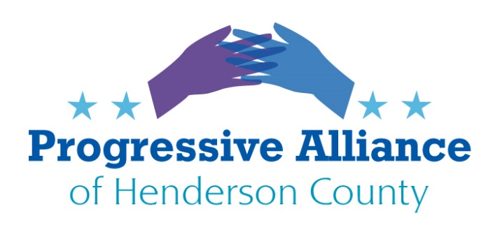
Virtual Postcard Party #212 March 12, 2021

NO Intelligence Briefings for Trump
Write the Director of National Intelligence to stop any and all intelligence briefings for trump. He didn’t understand them when he should have, and there’s no telling to whom he would brag about the wrong thing. It is always about him and getting money, not about our nation’s security.
https://www.dni.gov/index.php/who-we-are/leadership
Avril Haines
Director of National Intelligence
Washington, DC 20511

Corporate Raiders
Why is it legal for holding companies, hedge funds and other corporations to buy another company, and saddle it with debt in all sorts of clever and destructive ways? Plus paying the CEOs ridiculous salaries when hollowing out the target company. Then they declare bankruptcy, leaving vendors and creditors holding the (empty) bag.
Write Congress to enact laws preventing these corporate raider.

Supreme Court
Congress needs to pass laws against widespread, organized voter suppression. Congress has abdicated its legislative and policy responsibilities to the Supreme Court, which is currently determining many of our important policies and usually rules against protecting people’s right to vote.
Write members of Congress to do their job, acting in the best interests of all Americans.

Education
A recent Business North Carolina had a column about an organization called MyFutureNC. Its goal is to get 2 million North Carolinians a credential by 2030, e.g. at least a community college certificate or associate degree. This would mean 300,000 to 400,000 more people earning these credentials beyond the number already projected to do so.
The goals for each county vary. Whether it is helping low performing schools or having more 4 year-olds in Pre-K, or increasing the number of college and career ready scores in math for 3-8 graders.
If North Carolina has a world-class workforce, companies will come for our talent, while the argument for tax breaks will be greatly weakened.
Write our State reps, as well as Gov Cooper and insist that education be restored to the top of our State’s priorities. The future of our children and grandchildren depends on a strong economy here.

District Attorney Greg Newman
Review the Times News article- Alleged child rape survivor critical of DA, Tuesday, March 9, 2021
About a rape victim, age 5-12, and how District Attorney Greg Newman lied to reduce charges for her assailant. DA Newman was appointed by Pat McCrory and was reelected in 2014 and 2018. Last November the North Carolina State Bar Association handed Newman a three-year stayed probation for lying and other infractions. Yet Newman continues to serve Polk, Henderson and Transylvania counties. Decide whether the facts make DA Newman unfit to serve our county as a district attorney.

To file a complaint with the State Bar Association, you can find information here -https://www.ncbar.gov/for-the-public/i-am-having-a-dispute-with-a-lawyer

To contact the State Ethics Commission, you can find information here - https://ethics.nc.gov/complaints

Sheriffs to assist ICE
Republican Senator Chuck Edwards sponsored a bill to force NC Sheriffs to assist ICE, which passed the Senate last night and is headed to the NC House. North Carolina Republicans are again trying to force county sheriffs to hold a defendant who may be in the country illegally. Buncombe County Sheriff Quentin Miller who opposes the bill says it is important for members of the community to feel safe when calling the sheriff’s office for assistance. He says that immigration laws are not part of sheriffs’ law enforcement duties. ICE is inappropriately placing administrator duty and financial burden on sheriffs.
Write our state representatives and Sheriff Griffin to oppose this bill.

