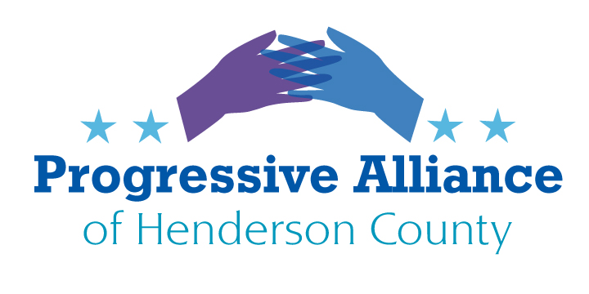

VIRTUAL POSTCARD PARTY #182 July 17, 2020

FEDERAL / STATE / LOCAL
SUPPORT THE HEROES ACT
The Heroes Act passed the House of Representatives in May with about $375 billion for state and local governments that have already laid off many thousands of workers and will have to lay off hundreds of thousands more having lost billions in tax revenues because of the Coronavirus Pandemic Recession.
Moscow Mitch McConnell now says the Senate will work on a follow-on pandemic relief bill starting July 20. But that bill cannot be allowed to penalize people in every hamlet, village, town, city, and state if it excludes major funding for state and local governments. We cannot allow Moscow Mitch to achieve his wish to strangle public safety, public schools, the social safety net, and public employee unions.
Contact Sheriff Lowell Griffin, and Police Chief Herbert Blake to urge them to publicly advocate with Sen. Burr and Sen. Tillis for passage of the Heroes Act. Contact County Commission Chair Grady Hawkins, Fletcher Mayor Ron Whiteside, Laurel Park Mayor Carey O'Cain, Mills River Mayor Chae Davis, and Hendersonville Mayor Barbara Volk to urge them to publicly advocate with Sen. Burr and Sen. Tillis for passage of the Heroes Act.
For contact information, please go to:
https://www.hendersoncountync.gov/county/page/henderson-county-municipalities
FYI:
Rod Whiteside:
Mayor, Town of Fletcher, 300 Old Cane Creek Rd, Fletcher NC 28732

Carey O'Cain:
Mayor, Town of Laurel Park, 441 White Pine Dr, Laurel Park NC 28739

Chae Davis:
Mayor, Town of Mills River, 124 Town Center Dr, Mills River NC 28759

STATE

THANK GOVERNOR COOPER FOR STANDING FIRM TO ADDRESS NORTH CAROLINA’S COVID-19 CRISIS BASED ON SCIENCE AND NOT ON POLITICAL GRANDSTANDING; THANK COMMISSIONER OF HEALTH MANDY COHEN AS WELL

North Carolina has made incremental progress towards reopening our economy based on public health evidence. We have seen the coronavirus pandemic overwhelm the Southeast. Fortunately we are not close to the extreme crisis engulfing Florida and Georgia, among others. Yet while our state has implemented appropriate guidance, we still face rapidly rising cases, hospitalizations, and deaths.

Contact Gov. Cooper to thank him for his measured leadership. Ask him to remain firm in basing policy on evidence, making hard choices thoughtfully and not recklessly. Please also contact Dr. Mandy Cohen, Secretary of the North Carolina Department of Health and Human Services to thank her for her leadership and the clarity of her communications.

Mandy Cohen, MD, MPH
2001 Mail Service Center
Raleigh, NC 27699-2000

On a related topic, please send feedback to Gov. Cooper’s Task Force for Racial Equality in Criminal Justice (TREC):
https://governor.nc.gov/issues/public-safety/trec-public-feedback-form .
LOCAL

PASS HB1200 NOW, IN SPECIAL SESSION, TO PROVIDE RELIEF FOR TENANTS & HOMEOWNERS FACING EVICTION OR FORECLOSURE

Democrats introduced House Bill 1200 to extend relief for individuals facing eviction or foreclosure: to help people maintain adequate and secure housing when they’ve lost income through layoffs and business closures. The unemployment rate in Western North Carolina was over 15% in April and May and is unlikely to substantially improve as long as the pandemic depresses employment throughout the region, state, and nation.

NC Senator Chuck Edwards disparaged HB1200 in the July 12 Asheville Citizen Times, carrying on his ostrich-like insistence that North Carolina should allow businesses to reopen and “get them back to work.” Per Robin Merrell at Pisgah Legal Services “North Carolina is sitting on millions of dollars from the Cares Act… [HB1200]…would have offered $140 million for rent payment [and] $60 million for mortgage payments.”
Rep. Brian Turner (D-Buncombe) (an HB1200 cosponsor) said, “The challenge that I’ve found is that…we have not been able to get an agreement on actually helping…individuals. There has been…a lot of work done to help businesses, but there has been little done to directly help individuals. This is one of those programs where people could apply for grants to help with mortgages or with rent, so this would go directly to people.” Republicans have raised the “strawman of fraud” to scuttle HB1200. Turner said, “…you’ve got people who would let 99 people go homeless to prevent one person who didn’t deserve the money to get it.”
Contact Sen. Chuck Edwards and Rep. Chuck McGrady telling them to support a special legislative session now, and asking them to approve HB1200 immediately.

