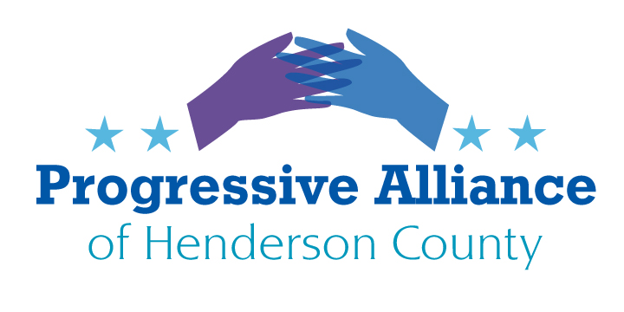

Postcard Party # 149 Nov. 29, 2019

Please note: Please continue to write concisely and in a civil but direct tone. The civil tone can be most productive in communicating with local officials who apparently personally read our postcards, whereas the federal officials generally just count numbers for and against specific legislation or issues.

CONSTITUENTS RESPONSE LOGS

Since this will likely be a slow news week, try this novel idea that came in from a PAHC stalwart. Write Senators Tillis or Burr or Representative Meadows, or McGrady, Edwards, Johnson: Ask them to provide the log book counts for communications they have received from their constituents regarding a specific issue of interest to you. For example: gun safety, immigration, infrastructure, military, building the wall, etc. If/When they write you back please share the information with Sheila or Nancy for publication in PAHC Newsletter, FB and Website.

National

Patriot Act Extension (from Real News Network)

“Today, we take an essential step in defeating terrorism while protecting the constitutional rights of all Americans.”
That was President George W. Bush when he signed the U.S.A. Patriot Act into law in October of 2001, shortly after the 9/11 attack. The U.S. Congress is now in the process of passing a renewal of this Patriot Act. Democrats propose the renewal in a tiny subsection of a stop gap government funding resolution so that there would be no government shutdown for at least another four weeks. The Patriot Act, which civil liberties have condemned for its wide-scale warrantless wiretapping provisions, was scheduled to expire on December 15th of this year. The renewal extends the law for another three months until March 15th, 2020.
Since its passage, many of its main provisions have been declared unconstitutional. However, a key controversial section, number 215, remains in place, which allows the government to collect phone metadata without court authorization.
Write Tillis, Burr, and Meadows to request that renewals of the Patriot Act be removed from future budget bills. Suggest instead that the Act be addressed as a stand-alone issue.

Decriminalizing Marijuana (from CBS News)

The House Judiciary Committee has passed a bill to decriminalize marijuana at the federal level and create a process for expunging convictions for cannabis crimes. Several other committees will report on this bill, including Oversight and Reform, where Mark Meadows is assigned.
The Marijuana Opportunity Reinvestment and Expungement (MORE) Act (HR 3884) is one of the broadest marijuana reform bills introduced in Congress in recent years.
If passed, the MORE Act would decriminalize pot at the federal level by removing it from the Controlled Substances Act and assess a 5% sales tax on marijuana with revenue allocated to an Opportunity Trust Fund (OTF).
House Democratic leaders haven’t indicated if, or when, the MORE Act will reach the House floor, but it could be considered as soon as early December when lawmakers return from the Thanksgiving recess. Write to Rep, Meadows to encourage him to support this effort.

North Carolina

Restoring Voting Rights to NC Felons

Dennis Gaddy missed out on the opportunity to elect the nation’s first African-American president because of his criminal record, despite re-entering society, paying taxes, taking care of his children and being a responsible and respected citizen.
After losing the right to vote for seven years, he’s now a lead plaintiff in a lawsuit challenging the statute that took away that “sacred” right, even after he served his time and “fully returned to society.”
The statute, enacted in 1971, continues to make it illegal for any person convicted of a felony to vote if they are still on probation or parole.
The lawsuit asks the court to declare the felony disenfranchisement law unconstitutional and to enjoin the state from preventing North Carolina citizens released from incarceration or not sentenced to incarceration from registering to vote and exercising the right to vote based on their felony conviction.
Write to McGrady, Jake Johnson and Edwards and ask them to start an effort in the NCGA to amend this statute (§ 163-55. Qualifications to vote; exclusion from electoral franchise.).

Anti-Hurricane Infrastructure Improvement
ReBuild NC has opened a second public comment period to receive citizen input on the draft Mitigation Action Plan for spending $168 million in Community Development Block Grant–Mitigation funding allocated to North Carolina by the U.S. Department of Housing and Urban Development. Under federal guidelines, the funds must be used to implement community projects that strengthen local infrastructure and reduce future losses in areas impacted by hurricanes Matthew and Florence. This funding is separate from the HUD CDBG-DR funding that was provided to the state for assistance to individual households.
The full draft of the Action Plan can be read at https://files.nc.gov/rebuildnc/documents/Mitigation/NCORR-CDBG-MIT-Action-Plan_FINAL_V1.pdf?utm_medium=email&utm_source=govdelivery
Public comment is open until December 23, and feedback can be sent via email (publiccomments@rebuild.nc.gov) or in writing (Mitigation Action Plan, P.O. Box 110465, Durham, NC 27709).

Reinstate the NC Earned Income Tax Credit (from NC Justice Center)
Reinstating North Carolina’s Earned Income Tax Credit (EITC) as a refundable credit at the national average of 20 percent of the federal credit has potential to improve life for the 900,000 North Carolinians who are working for low wages that erect barriers to their economic security and health. EITC participation enables better maternal & child health, healthier diets, decreased depression. Let Edwards and Jake Johnson know.

