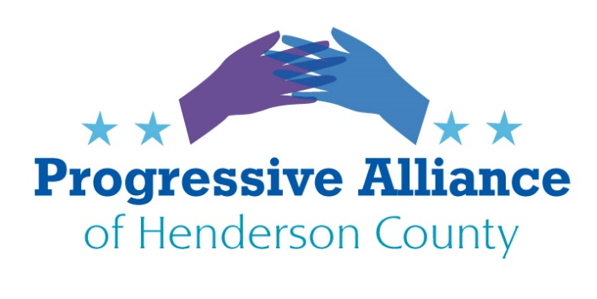 

**POSTCARD PARTY 163 MARCH 6, 2020**

**National**

**NEW LEGISLATION PACKAGE PRESENTS A PATH TO PEACE**

Onetime war refugee and Minnesota Progressive Rep. Ilhan Omar offered seven bills last month to shape a more constructive American path, to avoid and mitigate conflicts. A **Stop Arming Human Rights Abusers Act** (HR 5880) would define and recognize levels of gross human rights or humanitarian law violation. Crossing these lines triggers prohibition of security aid, arms sales when enabled by the U.S. government, or law enforcement exchanges. A **Global Migration Agreement Act** (HR 5878) tells the State Dept. and the U.N. Ambassador to take the lead in developing international ties governing global migrations. A **Congressional Oversight of Sanctions Act** (HR 5879) requires joint-resolution approval of any economic-emergency sanction within 60 days of the next sitting of Congress, and subjects sanctions now in force to Congressional renewal. Two resolutions would ratify the **U.N. Convention on the Rights of the Child** (H. Res. 854; the U.S. is alone in holding back on this) and restore U.S. support to enable the **Rome Statute/International Criminal Court** (H. Res. 855)**,** a controversial body that has indicted the former dictator of Sudan, Ugandan rebel leader Joseph Kony and over 40 others. Omar argues that ‘we can improve the court by being members of it’, a reversal of Trump Administration visa and economic restrictions on court activity. A bill (HR 5877) would internationalize the well regarded **Youthbuild Program** to enhance opportunities for disadvantaged persons to attain self-sufficiency. A**Global Peacebuilding Act** (HR 5948) would move $5 billion from Pentagon contingency funds to create a ‘Global’ multilateral fund as ‘an effective alternative to military intimidation and coercion’.

Many or all of these bills are in the House Foreign Affairs Committee where Omar is a member. **Eliot Engel** (D-NY) is committee chair. **Contact him and Rep. Meadows.**

**From NC Progress Action 3/2/20**

**ICE raids increase in North Carolina as Trump weaponizes the DOJ**  
North Carolina communities are taking a stance against Trump’s Immigration and Customs Enforcement increased presence and arrests. Since January, ICE has targeted immigrants in 12 counties across the state. ICE agents detained 32 people, 16 in Raleigh, prompting city leaders and immigrants to speak out against their increased actions. Last week, the DOJ announced the official section that would strip citizenship from naturalized citizens.

1. This move gives the Trump administration more power in their efforts to remove immigrants from the country.
2. Since 2008, 40 percent of denaturalization cases that the department filed, were filed in 2017 -- when Trump assumed office.
3. Data released in 2019 by the U.S. Immigration and Customs Enforcement, found that ICE has steadily been arresting more immigrants who lack a criminal record.

In the past two years, the percentage of those arrested who lack criminal convictions or pending charges, are up almost 50 percent for the Southeast.

Trump’s efforts violate the constitutional rights and safeguards that are meant to prevent arbitrary and abusive use of denaturalization. **Contact your MOCs to express your opinion.**

**North Carolina**

**SAFEGUARD OUR DRINKING WATER**

Coastal North Carolina around Wilmington has seen heavy coverage of contaminant GEN-X, a chemical made by Chemours, a spin-off of DuPont, used in making Teflon-like products near Fayetteville. GEN-X is currently in excess of the current State standard of 70 parts per trillion in much of Brunswick and New Hanover counties’ waters. In Charlotte, Albemarle, Fayetteville, Raleigh, Holly Springs, Sanford, Dunn, Goldsboro and Greenville other PFAS compounds exceed the state standard. Near the Wilmington drinking water intake levels of nearly 2000 times the state standard have been measured. GEN-X is a PFAS compound of great stability and newly recognized toxicity: There are about 175 such compounds known, and toxicologists hope to limit production and dispersion of the whole class of these chemicals. **The House has passed the PFAS Action** **Act of 2019** as a first effort at control, HR 535**.** Late last year the House attached PFAS regulation into the must-pass Nat’l Defense Authorization Act, but it was stripped out in conference.

HR 535 has been referred to Senate Committee on Environment and Public Works. Its subcommittee on Waste Management has nine members. Subcommittee member **Sen. Richard Shelby (R-AL), should be reminded** that his state includes many known areas of PFAS contamination in water, including in the communities of Trinity, Hatton, Moulton, Florence, Huntsville (airport), Cullman, Albertville, Gadsden, Rainbow City, Southside, Birmingham (airport), Westover, Clanton, Prattville and Millbrook. Minority subcommittee members Sens. Cory Booker (NJ), Kirsten Gillibrand (NY), Edward Markey (MA) and ranking member Thomas R. Carper (DE), may also be asked to encourage subcommittee chair Sen. Mike Rounds (R-SD) to bring this bill forward. As much of the use of PFAS has to do with military air safety (“foaming the runway” involves use of PFAS compounds), please consider supporting research into safer alternatives

**By Kirk Ross, Carolina Public Press, Published: March 3, 2020**

A new N.C. House committee, charged with reviewing local residential permitting and planning, opened hearings last week with an aim to “streamline” permitting and create a more uniform approach across the state. Rep. Mark Brody, R-Union, who chairs the new House Select Committee on Residential Planning and Permitting, said he intends to file a bill in the upcoming short session to reduce the amount of regulations imposed on developers and builders by local governments.

Local governments are abusing the permitting authority given to them under conditional use permits and other planning tools, Brody told Carolina Public Press in an interview after the committee’s initial hearing last week. Brody, who is a licensed general contractor, said the state needs a more uniform approach to give builders and developers more certainty going into a project. Right now, he said, local governments aren’t constrained.

**Action: Contact Rep. McGrady and Sen. Edwards to protest this effort by developers to forbid localities from setting their own, higher standards than the NCGA allows.**