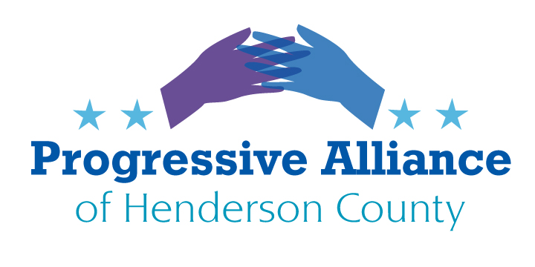
Virtual Post Card Party #235 February 15, 2022
#1. The updated Violence Against Women Act: S. 3623. Introduced, on the books since 1994, last updated 2014. Senators Burr and Tillis are both among 21 cosponsors of this update. Includes “meaningful steps to address the crisis of missing and murdered Indigenous people”. Updated to give more protection to Native American women, “most notably by expanding tribal criminal jurisdiction”. A version passed the House in March 2021 as H.R. 1620. Please write in favor of Senate passage and reconciliation with House version.

#2. Student Debt: Can the U.S. Department of Justice avoid contesting a bankruptcy court decision to cancel student loan repayment as part of a bankruptcy? The Daily Poster reported the federal Department of Education says contesting motions from DoJ are a ‘procedural matter’. Daily Poster notes that President Biden during his campaign agreed with Sen. Warren that bankruptcy relief of student debts was appropriate in cases of demonstrated ‘undue hardship’. Please write the Civil Litigation office of DoJ to remove itself from these cases, with CC: to President Biden. ---And follow up by urging Senators Burr and Tillis to sign on to bipartisan bankruptcy reform, including some alleviation of student debt burdens, via the ‘Fresh Start to Bankruptcy Act of 2021’.

#3. Voiding Internet Privacy: Sen. Graham (R-SC) two weeks ago introduced ‘A bill to establish a National Commission on Online Child Sexual Exploitation Prevention, and for other purposes’, known as the EARN IT Act, S. 3538. It’s progressing in the Senate, 21 cosponsors, and reported favorably from Judiciary Committee. An identical House bill,
H.R. 6544, has only four sponsors/cosponsors.
Here’s Joe Mullin at the Electronic Frontier Foundation: “Earlier today, the Senate Judiciary Committee voted to advance the dangerous EARN IT bill. We’re disappointed to see the committee advance this misguided bill. If enacted, EARN IT will put massive legal pressure on internet companies both large and small to stop using encryption and instead scan all user messages, photos, and files.
“The bill could now be voted on by the full Senate at any time, or worse, included as part of a different ‘must-pass’ legislative package. We need you to contact your representatives in Congress today to tell them to vote against this bill. TAKE ACTION”
Neither North Carolina Senator has a known position on this. Please ask Burr and Tillis to oppose this.
The EARN IT Act threatens free speech online by taking aim at Section 230 of the Communications Act of 1934 (as amended, 47 U.S.C. § 230), which generally shields online intermediaries from liability for the content users convey on their platforms. This helps to promote free expression online, which is further supported by the use of strong end-to-end encryption. Section 230 has never been a bar to federal criminal prosecution of intermediaries and current federal law imposes criminal liability on service providers who have knowledge that they are distributing child sexual abuse material (CSAM). And current law requiring providers to report these images results in millions of reports to the National Center for Missing and Exploited Children every year. EARN IT would repeal platforms’ Section 230 liability shield for any state criminal and civil law prohibiting the “distribution” or “presentation” of CSAM.
What does that mean in English?
It means states can write laws allowing them to prosecute internet platforms for material that they don’t even know is on their platform. It will force those providers to strictly censor their users’ speech on their platform - which we know from past experience with SESTA/FOSTA will adversely impact LGBTQ users and sex workers.
The bill would also jeopardize encryption. It would allow courts to consider the offering of end-to-end encrypted services as evidence to prove that a provider is complicit in child exploitation crimes. That’s a huge disincentive to offering encryption!

Addresses:
U.S. Senator Richard Burr, 217 Russell Senate Office Building, Washington, DC 20510
OR Federal Building, 151 Patton Ave., Suite 204, Asheville, NC 28801 (by app’t only)
DC Phone (202) 224-3154

U.S. Senator Thom Tillis, 113 Dirksen Senate Office Building, Washington DC 20510
OR 1 Historic Courthouse Square, Suite 112, Hendersonville, NC 28792 (by app’t only)
DC Phone (202) 224-6342 FAX (202) 228-2563

U.S. Department of Justice, Civil Division, 950 Pennsylvania Avenue, N.W., Washington, DC 20530-0001
by email Civil.Feedback@usdoj.gov

