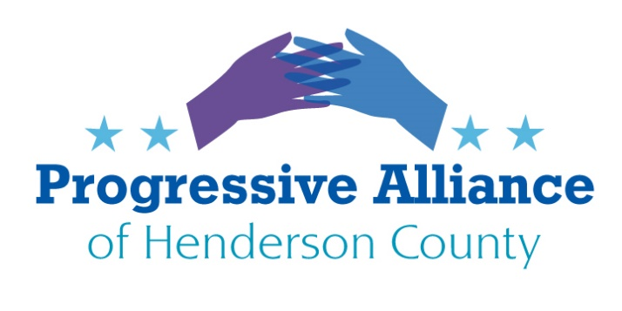

Postcard Party # 142 October 11, 2019

National

MEDICARE
President Trump just announced a plan to give corporate health insurers more control over your health care. His new executive order calls for “market-based” pricing, which would drive up costs for everyone with Medicare, eviscerate traditional Medicare, and steer more people into for-profit “Medicare Advantage” plans.
In the last few years alone CMS’ limited audits have highlighted major issues with Medicare Advantage plans. Reports from the Department of Health and Human Services Office of the Inspector General (OIG) and Government Accountability Office (GAO) have underscored these issues. They have recommended that CMS increase its oversight of Medicare Advantage plans and its enforcement efforts.
Contact Senators Burr and Tillis, and Rep. Meadows, to express your opinion on these changes to Medicare.

U.S. BILLIONAIRES NOW PAY LOWER TAXES THAN WORKING PEOPLE
For the first time in history, U.S. billionaires paid a lower tax rate than the working class last year. WaPo: “A new book-length study on the tax burden of the ultra-rich begins with a startling finding: In 2018, for the first time in history, America’s richest billionaires paid a lower effective tax rate than the working class. ‘The Triumph of Injustice,’ by economists Emmanuel Saez and Gabriel Zucman of the University of California at Berkeley, presents a first-of-its kind analysis of Americans’ effective tax rates since the 1960s. It finds that in 2018 the average effective tax rate paid by the richest 400 families in the country was 23 percent, a full percentage point lower than the 24.2 percent rate paid by the bottom half of American households. In 1980, by contrast, the 400 richest had an effective tax rate of 47 percent. In 1960, their tax rate was as high as 56 percent. The effective tax rate paid by the bottom 50 percent, by contrast, has changed little over time.

Contact Senators Burr and Tillis, and Rep. Meadows, to express your concerns about the tax policies under the Trump administration.

DICK’S DESTROYS $5M GUN INVENTORY
CNN: “Dick’s Sporting Goods has destroyed $5 million of the chain’s gun inventory, its CEO said. After finding out that Dick’s had sold the Parkland shooter a shotgun, CEO Edward Stack decided last year the company would no longer sell firearm to anyone under 21. Dick’s announced it would destroy its inventory of weapons, rather than allow them to be sold by another retailer. Since then, about $5 million of the chain’s gun inventory has been turned into scrap metal, Stack said in an interview with CBS.

Write CEO Stack and thank him for putting ethics ahead of profits. Dicks Sporting Goods 345 Court St. Corapolis, PA 15108

ABORTION
Even though this year’s state abortion restrictions have been consistently blocked, people across the United States who are seeking abortion care or who may become pregnant shouldn’t have to live in fear waiting for the other shoe to drop.
Thankfully, there is a bill to protect abortion access in Congress. The Woman’s Health Protection Act (WHPA) would create safeguards against harmful abortion bans and allow doctors to provide abortion care without medically unnecessary restrictions like those being reviewed in June Medical Services, LLC v. Gee.
WHPA was introduced in Congress in May. Despite having widespread support with 212 cosponsors in the House (HR 2975) and 42 in the Senate (S 1645), it is currently stalled in committee in both chambers.

Contact Senators Burr and Tillis, and Rep. Meadows, to demand that they push the Act for approval. NC Representative G.K. Butterfield is vice-chair of the House Health subcommittee; ask him to support the bill, perhaps by holding a hearing. Senator Burr is on the Senate subcommittee for Primary Health.

CLEAN CAR STANDARDS
The Trump administration just finalized their attack on states’ long-standing authority to implement strong clean car standards—the same standards that cut climate pollution, help us breathe clean air, and save Americans money at the gas pump. The Clean Air Act gives states authority to enforce protective clean car standards. The Trump administration’s attack on their authority is reckless, especially when a bipartisan coalition of states across the country are helping drive clean car solutions that reduce pollution.

This attack on public health and safety begs for congressional oversight. Your voice is needed to ensure clean car standards are kept in place.

Contact Senators Burr and Tillis, and Rep. Meadows, to encourage their support for the environment.

State / Local
UTILITIES
If you buy electricity from Duke Energy Corp. or own stock in the Charlotte-based utility, this week may be among the most important in a long time. The N.C. House of Representatives is expected to vote on a major change in how state regulators set electricity rates after a bill cleared the state Senate last week.
Duke has pushed hard for the changes, which it says are needed to help usher in a modernized electric grid, new technologies and cleaner energies. Some key Republican leaders favor the move.
Much of the controversy over Senate Bill 559 involves allowing the N.C. Utilities Commission to approve electric rate increases up to three years in advance and offer more flexibility when utilities exceed their allowed profit. In short, lawmakers are being asked to give Duke a bit more rope in how it operates, though there’s much disagreement over how much regulatory shackles will be loosened.
Contact NC Reps. McGrady and Jake Johnson to express your concerns about SB559, and urge that the Assembly not adopt the conference report on this bill.

