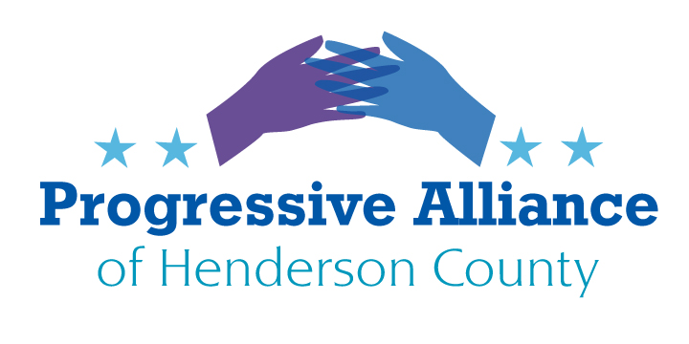
VIRTUAL POSTCARD PARTY #206 January 28, 2021

Republicans never seem to rest in flip-flopping. Just this week, House Minority Leader Kevin McCarthy (R CA) said it was shameful that Biden’s first action was to protect illegal immigrants over our own citizens. Senator Susan Collins (R MA) said about the 1.9 trillion dollar bill to help Americans, why would we need a package that big. They must think everyone doesn’t remember what they say. We must Keep Persisting and calling out their lies.
Cuban Travel Renewal
With the election of Joe Biden/Kamala Harris there is an expected return to the gradual liberalization of relations with Cuba. At least there would appear to be the prospect of the restoration of cruises, flights and remittance privileges, which advanced under President Obama but were scrapped under trump because of conservative pressure. Anything that trump did by executive order can be undone by the new administration.
Opposition remains alive and well from some Cuban-American factions. They turned out in record numbers for trump in the 2020 election, spurred by the continued drum beat by conservatives against the “Socialist” regime 90 miles from the US. Younger Cuban-Americans don’t seem to have the zeal of their more traditional brethren. The question is, however, how do Biden/Harris build momentum for 2024 in Florida while tension is still high against more normalized relations with Cuba? The irony is we have cooperative dealings with communist regimes in China, Viet Nam and Laos, but Cuba is off limits because of domestic politics, i.e. the Cuban-American electorate.
How this will play out will depend on how much value a Cuban/USA détente has to our politicians, think big business opportunities, versus the reactionary groups in Florida and Washington.
Write Biden/Harris plus our congressional representatives to revive improved relations with Cuba.
Immigration Policies Revamp
- Clear, Consistent Policies
It is no secret to anyone who has the slightest interest in what our immigration policies should be that these four long years with trump have been a disaster for not only hopeful immigrants, but for our populace as well. The trump administration’s actions to restrict legal immigration certainly centers around white nationalism, led by Stephen Miller. Can anyone recall a more disjointed, confusing, vindictive and harmful stance toward legal immigration in this country?
What has become one of our lowest points in American history cannot be ignored, but it is time to look forward. Even under Obama there were actions taken that not all Americans could be proud of. The biggest flaw in our immigration policies seems to be a lack of consistency. Nearly every other advanced country in the world has defined policies for how citizens from other countries can or cannot qualify for legal residence in their country. Have illegals entered this country in large numbers over the last 50 years? Of course, but not all have come from south of our borders.
Overturning trump’s most egregious actions won’t be enough to turn the situation around. We are still very attractive to low income aspirants for entry but other desirable destinations like Canada and New Zealand have well defined standards for immigration based on job skills and employability. They, like us, have an open door policy for people with money who agree to invest in their economies, just as before and also have special programs for qualified refugees.
The United States’ population dwarfs that of Sweden, Norway and all other advanced countries so we must come up with policies that serve our needs but also accommodate as many other immigrants as we can reasonably allow. We are fundamentally a country of immigrants and if our country is so good, can’t we figure this out? We can’t take on the problems and challenges of everyone who would like to come here but we can surely develop advantageous, workable and benevolent immigration policies. We have to start by not assuming virtually everyone who wants to come here is not worthy, plus, working out sensible plans for those already here to remain.
Write Biden/Harris plus our congressional representatives

- Asylum-Seekers
Under trump, the administration announced that U.S. Citizenship and Immigration Services (USCIS) will start charging asylum-seekers a fee to apply for refuge in the United States.
The global community created asylum, a legal process that allows someone who feels their life is in danger to seek refuge in safer countries. This was enacted as a need during the Holocaust. Asylum laws are supposed to ensure that no one fleeing persecution in their home country is turned away when seeking refuge.
An officer working for USCIS said “Humanitarian applications by their nature should be free. The idea of charging people who are fleeing – and not helping if they don’t pay up- is disgusting.” The U.S. has signed the various treaties governing asylum requests, and it is time for us to uphold our word.
Write Biden/Harris and your representatives in Congress encouraging them to develop reasonable strategies, not creating more political footballs. Contact the head of Department of Homeland Security to overturn this draconian policy
- ICE and the Detention of Children
Seemingly lost in the Pandemic and the upcoming election are 120 children ordered by a Federal judge June 26, 2020 to be released within 30 days. According to the Flores Settlement, a 23 year old class action lawsuit which laid the ground rules for children’s rights held in immigration detention, children cannot be held for more than 20 days. Many children have been detained much longer; 47 children in a Texas facility have been incarcerated for more than 300 days. Increased cases of Covid among the ICE- held children are “on fire” according to the judge.
ICE and lawyers representing the children have been unable to agree on how to safely and humanely remove children from custody, which of course, in most cases, means removal from their incarcerated families. ICE could choose to release entire families to relieve the pain and danger of detention but have chosen not to. The judge originally gave ICE two options on June 26: release the children to sponsors with parental consent or release the parents and children together. So far, ICE has refused to release families together. The judge has admonished ICE for failure to comply with the ruling and find solutions to the problem.
Write Congress and demand that ICE comply with legal rulings, and above that, act with humanity and above political pressures from uncaring politicians.

