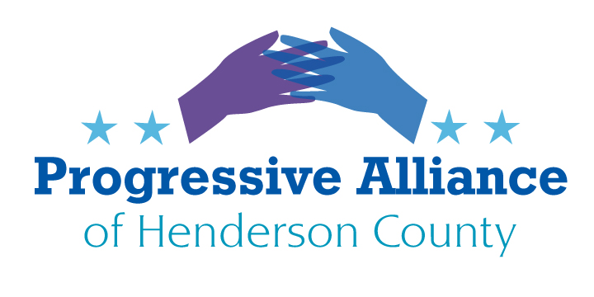

Virtual Postcard Party Suggestion Sheet #216 May 1, 2021

POLICE ACCOUNTABILITY
Which Approach Would You Take?
NEW YORK STATE:
On June 15, 2020, New York’s Governor Andrew M. Cuomo signed policing reform legislation requiring state and local law enforcement officers to report within six hours when they discharge their weapon (S.2575-B/A.10608); requiring courts to compile and publish racial and other demographic data of all low-level offenses (S.1830-C/A.10609); and requiring police officers to provide medical and mental health attention to individuals in custody (S.6601-A/A.8226).
"Police reform is long overdue in this state and this nation, and New York is once again leading the way and enacting real change to end the systemic discrimination that exists in our criminal justice and policing systems," Governor Cuomo said. "These critical reforms will help improve the relationship between law enforcement and the communities they serve and take us one step closer to righting the many injustices minority communities have faced because of a broken and unfair system."
Police Statistics and Transparency Act (S.1830-C/A.10609)
The Police Statistics and Transparency Act - or STAT Act - requires courts to compile and publish racial and other demographic data of all low-level offenses, including misdemeanors and violations. The data collected must be made available online and updated monthly. The new law also requires police departments to report any arrest-related death to the Department of Criminal Justice Services and to submit annual reports on arrest-related deaths to the Governor and the Legislature.
NORTH CAROLINA:
On Feb. 15, 2021, North Carolina State Senator Chuck Edwards introduced Senate Bill 100 that would reduce state funding to any local government that cuts spending for its police or sheriff’s office. The goal is to make it more difficult for local officials to heed calls to “defund the police” and shift money to social services and other programs.
“Regretfully, this sentiment which is now turned into violent behavior, is no longer found just on the streets of Minneapolis, New York and Philadelphia,” Edwards said. “We’re seeing radical extremists launch vicious attacks on enforcing our laws right here in North Carolina.”
Edwards’ bill would apply to cities, towns or counties that cut salaries or other expenses for law enforcement by more than 1% of the government’s budget that year.
The N.C. Police Benevolent Association issued a press release Monday afternoon expressing support for the bill that would protect law enforcement funding, saying Asheville was a “catalyst” for the legislation, when it voted to reduce the police department’s budget by $770,000 in September 2020. “This legislation is a necessary step to prevent elected officials from making harmful decisions that fail to support officers and their agencies,” NC Division President Randy Byrd said in a statement. “When you don’t support these officers and their agencies, it can lead to officers leaving in unprecedented numbers and violent crime increasing.”
Please write to Sen. Edwards to ask whether he would reject the New York State law that works to greatly increase police accountability, seeking to greatly reduce the incidence of police misconduct and avoidable harm to the public, especially people of color. One may suggest that if Sen. Edwards’ only approach to police accountability is to dictate to local North Carolina governments that they may not restructure law enforcement in any way that it may be time for Sen. Edwards to take his knee off of our necks.
PUBLIX ACCOUNTABILITY
It is well understood that Publix is not accountable for the actions of an heir to the founders of Publix for her disgraceful financial and ideological support of the Jan. 6, 2021 reactionary and racist insurrection at the U.S. Capitol. It is, however, Publix’s responsibility to join fellow major corporations---particularly in the Southeast---to vocally express their opposition to the epidemic of voter suppression laws working their way through state legislatures throughout the United States (including the new Jim-Crow-like law that is in effect in Georgia).
Please call the Publix Customer Care department at 800-242-1227 to seek a direct response to your request. One may also write to Publix Super Markets, Inc., P.O. Box 407, Lakeland, FL 33802, ATTN: Customer Care, or send an email at www.publix.com/contact.
DISMANTLE THE MEGA-CORPORATE FOOD CARTELS
From the Hightower Lowdown March-April 2021:
“…help break the grip of the corporate cartels squeezing the vitality out of the land, family farmers, farm and processing workers, and eaters, too.
“The Family Farm Action Alliance (farmactionalliance.org) connects and supports ‘unlikely allies’ in the food system, spreading awareness that abusive corporate power undermines a resilient and just food system…
“And check out the campaigns organized by Real Food Generation (realfoodgen.org). Its ‘Real Meals Campaign’ aims to transform the $18 billion college cafeteria industry by pressuring the Big Three contractors---Aramark, Sodexo, and Compass---to shift sourcing from industrial ag to smaller-scale and local suppliers and, in the process, fight climate change, racism, and inequality in the food chain.”
JUST A THOUGHT: IN THE NEWS
The Hendersonville Times News reported this past Sunday April 26, 2021 that “Mills River Town Council joined other government bodies in the state Thursday in opposing bills before the N.C. General Assembly that could diminish the number of single-family zoned properties without local government control.
“If passed into law, property owners would be able to develop ‘middle housing’ – duplexes, triplexes, quadplexes and townhomes – by right on properties zoned for single-family homes without local planning and…approvals.”
QUESTION FOR A PROGRESSIVE ALLIANCE:
Is there a feasible balance among development, local control, low income housing, and diversity in housing? This question may not be directly relevant to the legislation under consideration in the NC General Assembly and the reasons Mills River, Hendersonville, and other communities object to this legislation. But what ways do we have in Henderson County to increase access to housing (and the growth of intergenerational family resources) for people who have a great need but relatively low income? Now may be the time to start a conversation about these issues, recognizing that there is undoubtedly a diversity of opinions, experiences, and concerns within the PAHC.

