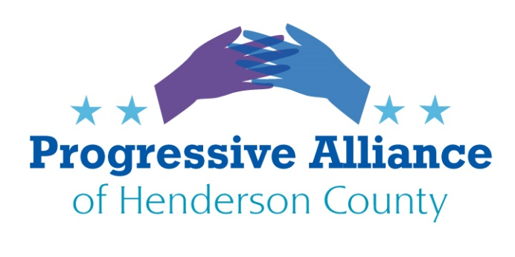
POSTCARD PARTY #147 NOVEMBER 15, 2019
NATIONAL
*Sen. Ben Cardin from Maryland and a growing list of co-sponsors have a resolution:
S.Res.404 — to have the U.S. rejoin the Paris Climate Agreement.
Contact: Burr, Tillis, Cardin, McConnell, WH
*HR.8 (Bipartisan Background Checks Act of 2019) passed the US House in February, but has yet to be voted on in the Senate. At almost the exact moment news broke of a school shooting yesterday in California, Sen. Chris Murphy (D-CT) made a Senate motion to consider (finally!) the gun background checks bill for a vote. The motion was blocked by Sen. Cindy Hyde Smith (R-MS). As per data compiled by the Gun Violence Archive, yesterday’s was the 334th mass shooting in America this year. 1,347 persons injured; 377 killed. 30 shooting events were at schools in 2019, according to Everytown for Gun Safety. Contact: McConnell, Burr, Tillis, Hyde Smith, Murphy.
Also, Edwards, McGrady, Johnson since NC legislators will reportedly soon be considering statewide gun violence legislation
*The Ukraine whistleblower (and some others who have been subpoenaed) report that they feel threatened. NC District 9 rep. Dan Bishop this week shared a name on social media of who he considers to be the whistleblower. The Whistleblower Protection Act of 1989, 5 U.S.C. 2302(b)(8)-(9), Pub.L. 101-12 as amended, is a United States federal law that protects federal whistleblowers who work for the government and report the possible existence of an activity constituting a violation of law, rules, or regulations, or mismanagement, gross waste of funds, abuse of authority or a substantial and specific danger to public health and safety. A federal agency violates the Whistleblower Protection Act if agency authorities take (or threaten to take) retaliatory personnel action against any employee or applicant because of disclosure of information by that employee or applicant. Contact: WH, Members of Congress, Dan Bishop
*Federal prosecutors began a retrial this week of humanitarian aid volunteer and immigration rights activist Scott Warren on two charges related to aiding migrants along the U.S.-Mexico border. This comes just a few weeks after a jury refused to convict Warren for providing water, food, clean clothes and beds to two undocumented migrants crossing the Sonoran Desert in southern Arizona. Eight jurors found Warren not guilty; four said he was. Federal prosecutors have dropped a conspiracy charge against him. If convicted on the two felony migrant harboring charges, Warren faces up to 10 years in prison. Contact: Mark A. Morgan, Acting Director U.S. Customs and Border Protection 801 9th St NW, Washington, DC 20001 also: Scott Warren c/o No More Deaths PO Box 40782 Tucson, AZ 85717
*DACA (as of this writing, Supreme Court has not yet ruled on termination of DACA) Immigration reform legislation is long overdue. The American Dream and Promise Act of 2019 (HR.6) passed the US House in June, 2019 and has yet to be brought to the floor of the Senate. Contact: McConnell, Burr, Tillis, WH
NORTH CAROLINA
*Congressional redistricting saga continues (no official announcement as of this writing)
Contact: Edwards, member of Joint Select Redistricting Commission established 11/4/19.
Co-Chairs: Rep. Destin Hall, Sen. Ralph Hise, Rep. David Lewis
*Senate President Phil Berger (R-Rockingham Co.) is defending himself against a State Board of Elections complaint filed against him which exposes how Berger has been using political campaign contributions to pay the mortgage on his Raleigh townhome. Berger claims the SBE has twice approved his campaign making the regular mortgage payments. But only Berger and another Republican, Tim Moore, the Speaker of the NC House, have used campaign money to make mortgage payments on property they own. Contact: McGrady, Johnson, Edwards, Berger, Moore, NC Board of Elections Chair Damon Circosta P.O. Box 27255 Raleigh, NC 27611-7255
LOCAL
*Henderson County 287(g) Steering Committee will meet December 10, 2019.
Let Sheriff Griffin and the county commissioners hear your views on the 287(g) program.
Meeting: 10:30-11:30 Henderson Co. Courthouse – Courtroom #2 Point of Contact: Julia Laughlin 828.694.3105
*County Commissioner Grady Hawkins chose to insert partisan rhetoric into remarks at a Veterans’ Day ceremony in Tuxedo. (from Times/News article, 11/12/19) “He said members of the military take an oath”... to support and defend the Constitution against all enemies, both foreign and domestic” before listing socialism and Islamic terrorism as America’s top two domestic enemies. Hawkins went on to say that socialism is “diametrically opposed to the Constitution” because of the notion of free enterprise, and that socialism has “a real track record of failures.
”He also said radical Muslims say their mission “is to destroy western civilization”.
Contact: Grady Hawkins
*Mid-term elections in Henderson County resulted in the election of some exciting “fresh, new faces”, particularly on Fletcher Town and Henderson City Councils. The disappointing voter turnout, however, proves there is WORK TO DO: Ballots Cast: 18.40% (4,766 out of 25,897)
contact: your neighbors, friends, colleagues -- REGISTER, VOTE!
2019 HENDERSON COUNTY MUNICIPAL ELECTION RESULTS RECAP:
Flat Rock Mayor: Nick Weedman
Village of Flat Rock Council: Thomas Carpenter, Anne Coletta, David Dethero
Fletcher Town Council: Preston Blakely, Bob Davy
Hendersonville City Council: Jennifer Hensley, Lyndsey Simpson
Laurel Park Mayor: J. Carey O’Cain
Laurel Park Town Council: George Banta, Robert Vickery
Mills River Town Council: Randy Austin, Roger Snyder
City of Saluda Council: Bob Ross, Stanley Walker

