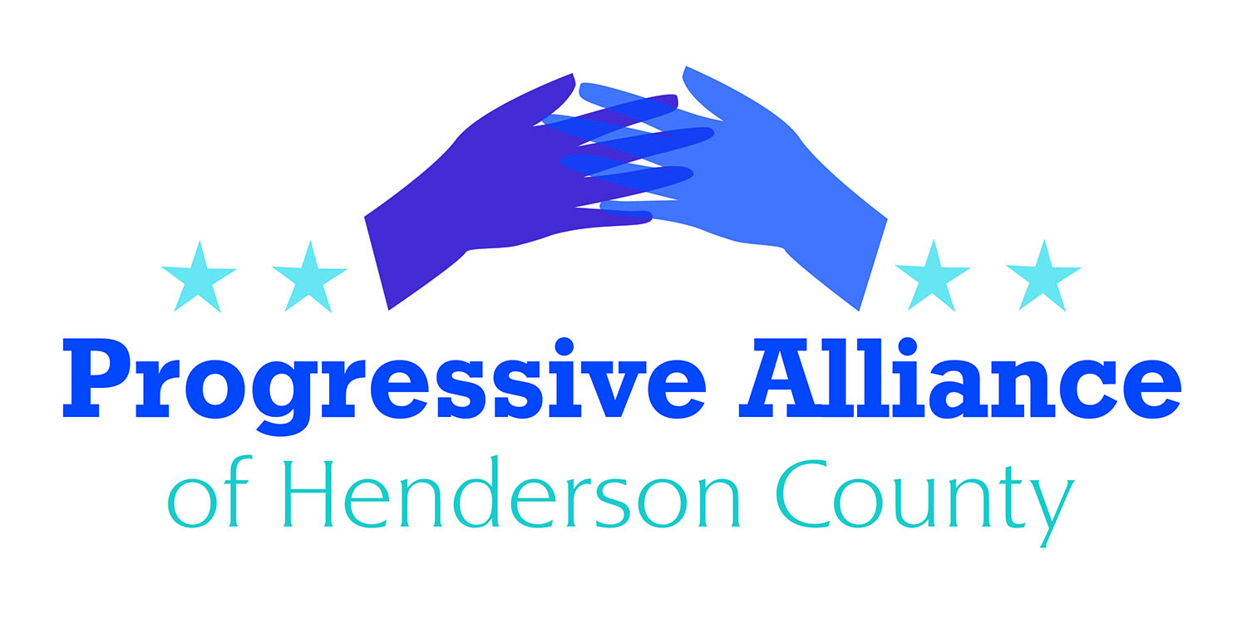

Postcard Party # 118 April 26, 2019

National

Breaking News: Humans Cause Climate Change
99.9999% chance humans are causing global warming, and other science-based facts on climate change for Earth Day. USA Today: “Climate change is real and increasingly a part of our daily lives. New research and studies out in just the past six months highlight the latest facts about the human-caused shift to our global weather systems and its effects on our planet. First among them, there’s no longer any question that rising temperatures and increasingly chaotic weather are the work of humanity. There’s a 99.9999% chance that humans are the cause of global warming, a February study reported. “It’s already underway,” said study lead author Matt Fitzpatrick of the University of Maryland’s Center for Environmental Science.”
Write to Rep. Meadows, Sens. Burr and Tillis, and/or Andrew Wheeler, EPA Administrator (EPA, 1200 Pennsylvania Ave. N.W., Washington, DC 20460)

FBI Arrests Armed Militia Leader At Border
FBI arrests leader of militia group that detained hundreds of migrants at gunpoint. ThinkProgress: “The FBI on Saturday arrested the leader of the heavily-armed vigilante group that had illegally detained over 300 migrants trying to cross the border from Mexico and into New Mexico. Larry Hopkins (AKA Johnny Horton Jr., Scott Alan Curtiss, and code name “Striker”) is the leader of the United Constitutional Patriots (UCP), a group that has been accused of impersonating law enforcement at the border. He was arrested in Oregon in 2006 on suspicion of impersonating law enforcement and for being a felon in possession of firearms. According to the FBI, Hopkins was once again charged this weekend with being a felon possessing firearms and ammunition. His arrest comes two days after New Mexico Gov. Michelle Lujan Grisham called for an investigation into the group’s activities and Attorney General Hector Balderas made clear that the the group ought ‘not attempt to exercise authority reserved for law enforcement.'”
Write to Rep. Meadows, Sens. Burr and Tillis, and/or Acting Secretary of Homeland Security Kevin K. McAleenan (DHS, Washington, DC 20528)

State

Three New Bills Introduced to end Gerrymandering
Legislation was filed in the NC Senate (S 641) and NC House (HB 574 and HB 648) recently that would allow voters to amend the North Carolina Constitution to create a citizens' commission to draw the state's congressional and state legislative districts every 10 years. This would replace the current system where the political party in power creates those districts.
Contact State Sen. Edwards and Rep. McGrady to express your opinion on this bill.

Using Student IDs for Voting
Quite a number of colleges and universities did not meet the guidelines and deadline for their students ID's to be used for voting, but the NC House passed a bill to offer more time. Campuses that failed to win approval for their student IDs to be used for voting will get more time and a clearer definition of the requirements under a bill approved last Thursday by the state House. In a 100-9 vote, the House gave approval to H646, which clarifies the requirements and extends the application deadline. Rep. David Lewis, R-Harnett, who chairs the House Committee on Elections & Ethics Law, told House members during debate Thursday afternoon that the legislation doesn’t change any of the policies on Voter ID but makes a necessary set of technical fixes to the process. The legislation now moves to the Senate. A statement Senate leader Phil Berger’s office said the Senate would act on the House bill or similar legislation this session.
Contact State Sen. Edwards to voice your support for this legislation.

Teachers Rally on May 1
With thousands of North Carolina educators preparing to once again march to the General Assembly on May 1 for better public school funding, a new poll finds widespread support for the educators’ demands among North Carolina voters.
The NCAE’s demands for the May 1 day of action include the following:
- Provide enough school librarians, psychologists, social workers, counselors, nurses, and other health professionals to meet national standards
- Provide a $15 minimum wage for all school personnel, 5% raise for all support staff, teachers, admins, and a 5% cost of living adjustment for retirees
- Expand Medicaid to improve the health of our students and families
- Reinstate state retiree health benefits eliminated by the General Assembly in 2017
- Restore advanced degree compensation stripped by the General Assembly in 2013
Whether or not you are attending any rally on May 1, contact Gov. Cooper and State Sen. Edwards and Rep. McGrady to express your opinion on this initiative.
Cooper vetoes bad-faith “Born Alive” bill
Gov. Roy Cooper has vetoed the latest Republican abortion bill, another attack on health care using sensationalist claims not based in science. Although the GOP no longer has super-majorities in both chambers of the General Assembly, they may still be able to scrape up the two-thirds majority necessary to overturn the veto. No matter what happens, one thing is clear: SB 359 is part of an extreme agenda that seeks to ban abortion outright.
Contact Gov. Cooper to thank him for his veto of this unnecessary bill. Also contact State Sen. Edwards and Rep. McGrady to express your opinion.
Atlantic Coast Pipeline
22 members of the NC legislature have asked the Federal pipeline regulatory authority to suspend the overall permit - a Certificate of Public Convenience and Necessity - and issue a stop work order on the Atlantic Coast Pipeline, a joint project of Duke Energy and Dominion Energy. The pipeline would run from fracked wells in West Virginia to Robeson County, NC. This design route was probably a stalking-horse for a plan to export gas that was not consumed by Duke's and Dominion's gas-turbine electricity plants.
Let's write letters of support for Rep. Pricey Harrison, the letter organizer, and our WNC legislators Sen. Terry Van Duyn and Rep. Susan Fisher, who supported this effort to keep a poor investment from continuing.

